|  |
| --- |
| Cybersecurity |
| Penetration Test Report |

Rekall Corporation

Penetration Test Report

## Confidentiality Statement

This document contains confidential and privileged information from Rekall Inc. (henceforth known as Rekall). The information contained in this document is confidential and may constitute inside or non-public information under international, federal, or state laws. Unauthorized forwarding, printing, copying, distribution, or use of such information is strictly prohibited and may be unlawful. If you are not the intended recipient, be aware that any disclosure, copying, or distribution of this document or its parts is prohibited.

Table of Contents

Confidentiality Statement 2

Contact Information 4

Document History 4

Introduction 5

Assessment Objective 5

Penetration Testing Methodology 6

Reconnaissance 6

Identification of Vulnerabilities and Services 6

Vulnerability Exploitation 6

Reporting 6

Scope 7

Executive Summary of Findings 8

Grading Methodology 8

Summary of Strengths 9

Summary of Weaknesses 9

Executive Summary 10

Summary Vulnerability Overview 51

Vulnerability Findings 52

CVE-2014-6271 52

CVE-2017-5638 53

CVE-2019-6340 54

CVE-2019-14287 55

CVE-2003-0264 56

CVE-2004-2730 57

Appendix 60

## Contact Information

|  |  |
| --- | --- |
| **Company Name** | Pen One |
| **Contact Name** | Kimberly N, |
| **Contact Title** | Penetration Tester |

## Document History

|  |  |  |  |
| --- | --- | --- | --- |
| **Version** | **Date** | **Author(s)** | **Comments** |
| 001 | Jan. 5, 2023 | Kimberly N. |  |

## Introduction

In accordance with Rekall policies, our organization conducts external and internal penetration tests of its networks and systems throughout the year. The purpose of this engagement was to assess the networks’ and systems’ security and identify potential security flaws by utilizing industry-accepted testing methodology and best practices.

For the testing, we focused on the following:

* Attempting to determine what system-level vulnerabilities could be discovered and exploited with no prior knowledge of the environment or notification to administrators.
* Attempting to exploit vulnerabilities found and access confidential information that may be stored on systems.
* Documenting and reporting on all findings.

All tests took into consideration the actual business processes implemented by the systems and their potential threats; therefore, the results of this assessment reflect a realistic picture of the actual exposure levels to online hackers. This document contains the results of that assessment.

### Assessment Objective

The primary goal of this assessment was to provide an analysis of security flaws present in Rekall’s web applications, networks, and systems. This assessment was conducted to identify exploitable vulnerabilities and provide actionable recommendations on how to remediate the vulnerabilities to provide a greater level of security for the environment.

We used our proven vulnerability testing methodology to assess all relevant web applications, networks, and systems in scope.

Rekall has outlined the following objectives:

Table 1: Defined Objectives

|  |
| --- |
| **Objective** |
| Find and exfiltrate any sensitive information within the domain. |
| Escalate privileges. |
| Compromise several machines. |

## Penetration Testing Methodology

### Reconnaissance

### 

We begin assessments by checking for any passive (open source) data that may assist the assessors with their tasks. If internal, the assessment team will perform active recon using tools such as Nmap and Bloodhound.

### Identification of Vulnerabilities and Services

We use custom, private, and public tools such as Metasploit, hashcat, and Nmap to gain perspective of the network security from a hacker’s point of view. These methods provide Rekall with an understanding of the risks that threaten its information, and also the strengths and weaknesses of the current controls protecting those systems. The results were achieved by mapping the network architecture, identifying hosts and services, enumerating network and system-level vulnerabilities, attempting to discover unexpected hosts within the environment, and eliminating false positives that might have arisen from scanning.

### Vulnerability Exploitation

Our normal process is to both manually test each identified vulnerability and use automated tools to exploit these issues. Exploitation of a vulnerability is defined as any action we perform that gives us unauthorized access to the system or the sensitive data.

### Reporting

Once exploitation is completed and the assessors have completed their objectives, or have done everything possible within the allotted time, the assessment team writes the report, which is the final deliverable to the customer.

## Scope

Prior to any assessment activities, Rekall and the assessment team will identify targeted systems with a defined range or list of network IP addresses. The assessment team will work directly with the Rekall POC to determine which network ranges are in-scope for the scheduled assessment.

It is Rekall’s responsibility to ensure that IP addresses identified as in-scope are actually controlled by Rekall and are hosted in Rekall-owned facilities (i.e., are not hosted by an external organization). In-scope and excluded IP addresses and ranges are listed below.

# 

## Executive Summary of Findings

## 

### Grading Methodology

Each finding was classified according to its severity, reflecting the risk each such vulnerability may pose to the business processes implemented by the application, based on the following criteria:

**Critical**: Immediate threat to key business processes.

**High**: Indirect threat to key business processes/threat to secondary business processes.

**Medium**: Indirect or partial threat to business processes.

**Low**: No direct threat exists; vulnerability may be leveraged with other vulnerabilities.

Informational: No threat; however, it is data that may be used in a future attack.

As the following grid shows, each threat is assessed in terms of both its potential impact on the business and the likelihood of exploitation:

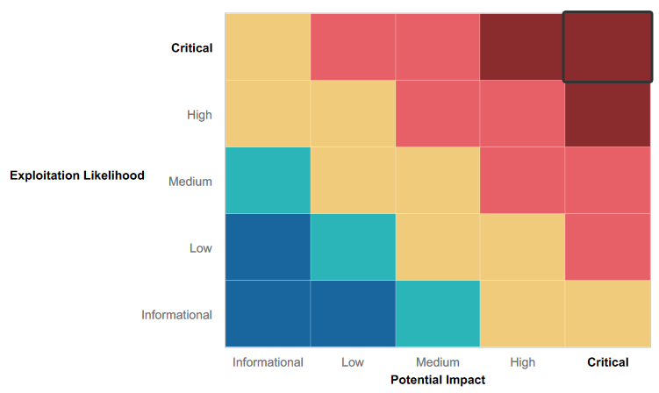

### 

### Summary of Strengths

While the assessment team was successful in finding several vulnerabilities, the team also recognized several strengths within Rekall’s environment. These positives highlight the effective countermeasures and defenses that successfully prevented, detected, or denied an attack technique

* Authentication and session management are setup ensuring only legitimate users can access the application, and servers.
* Authorization is setup for logging-in the webpage, and servers.

### Summary of Weaknesses

We successfully found several critical vulnerabilities that should be immediately addressed in order to prevent an adversary from compromising the network. These findings are not specific to a software version but are more general and systemic vulnerabilities.

* Login credentials were available in public websites or visible underneath codes.
* Input validation provided by user in web forms, query parameters, uploads, etc. needs to be validated and sanitized.

## Executive Summary

First, the focus is on attacking the web application to find vulnerabilities. Upon accessing the webpage, a cross-site scripting (XSS) attack was done (see Figures 1-3 for more information). This is where a malicious code is downloaded and executes the script such as: initiate interactions with other applications within the website, view any information that the user is able to view, perform any action within the web application that the user can perform; and modify any information that the user is able to modify. To test for every entry point within the web application’s HTTP requests, different parameters or data within URL query string and message body and URL path were tested.

The next attack to be completed was SQL injection via web page input (see Figure 4 for more information). This vulnerability allows attacker to submit queries to web applications’ database. SQL database in particular enables data retrieval and manipulation for relational databases. It allows attacker to view sensitive data that are not normally able to be retrieved and be able to modify the SQL query to return additional results such as information about how the database is organized and protected. A systematic set of tests were conducted against every entry point in the web application such as submitting single quote character, SQL specific syntax, Boolean conditions (i.e., 1=1 or 1=2), payloads to trigger time delays when executed within a SQL query, OAST payloads designed to trigger and out of bad network interaction when executed within a SQL query.

Moving into different pages of the website and using the tool called Burp Suite, illustrates sensitive data exposure (see Figure 8 for more information). There were several sensitive data exposures found during the Penetration testing engagement and will be further discussed later on. This type of vulnerability includes data transmitted in clear text; lack of Secure Sockets Layer (SSL) protocol to authenticate and encrypt data; outdated or weak encryption algorithms; and weak or default cryptography keys used.

A preliminary investigation of the Login Page and inspection of the HTML code behind the web app was completed next. It was found that by highlighting the webpage, there is sensitive data exposure (see Figure 9 for more information). Using the information gained from the HTML code, this led to a successful Login using Admin credentials (see Figure 10 for more information) and further exploitation is completed and will be explained more later on. Upon gaining successful access to the Administrator only accessible page, it led to accessing Networking tools to be exploited. Command injection was done (see Figures 5 and 6 for more information) to the DNS Checker and MX Record Checker. This web security vulnerability allows an attacker to execute arbitrary commands to the server and fully compromise the application and all its data. To execute the exploit, a number of characters was used, and they function as a command separator to allow commands to be chained together.

A web crawler traffic text file called robots.txt (see Figure 11 for more information) was found to be enabled and sensitive data information was found to be easily accessible. Using the information gained provided in this text file, a PHP injection attack was completed (see Figure 7 for more information). The code injected exploits a bug caused by processing invalid data and can result in data corruption, loss, denial of access or complete host takeover by the attacker. Various command inputs were crafted to modify the code to be executed and inject arbitrary code that the server can execute.

Remote or Local File Inclusion was the next attack to be completed (see Figures 13 and 15 for more information). This vulnerability allows an attacker to include a file to exploit a targeted application. It occurs due to the use of user-supplied input without proper validation. A file input downloaded into the server is normally flagged to be safe and trusted by the web application, but malicious attackers can include malicious PHP scripts. The application may fail to sanitize files prior to uploading into the server, which then gives an attacker a way to leave malicious contents in the files uploaded.

Once access to the Administrator only page has been gained as previously stated, this led to Directory Traversal attack (see Figure 17 for more information). Using the command injection vulnerability from earlier, sensitive information such as different web application pages were visible (see Figure 16 for more information), which allowed for a successful Directory Traversal attack. This also allows an attacker to read arbitrary files on the server that is running an application. It also allowed for an attacker to figure out the URL structure that the application uses to requests files. The URL paths were changed to gain access to different parts of the website.

Another way command injection attack was used was to display sensitive information such as usernames and passwords (see Figure 18 for more information). Using the information gained in this attack, Brute force attack was successfully done (see Figure 19 for more information) and gained access into the website using the credentials found during the previously stated attack. Brute force attack consists of configuring predetermined values using word lists or a traditional one using different classes of characters.

After successfully gaining access and logging-in the server using the credentials previously described, the tool Burp Suite was used again to get the correct session ID with the corresponding user credentials found earlier (see Figure 20 for more information). These are unique identifiers authenticating users and track their activities when using the web application.

The next focus to test is the Linux servers for vulnerabilities. By following through the MITRE ATT&CK framework for Enterprise, as shown in Figure 21, begin with Reconnaissance phase. In this phase, some of the techniques used are active scanning; gather the following victim’s: hosts, network information, identity information; search open and closed technical databases; and search open websites and domains. Doing a quick internet research for *totalrekall.xyz,* Figures 22 and 24 shows the information that was gathered and available openly to the public such as: Organization’s information: name, address, email, phone, domain name servers and the certificate respectively.

Continuing on using initial information gathered through research, active scanning of the system commences. By doing a query on the internet domain name server (see Figure 23 for more information), an IP address is used to complete a network scan using the tool nmap (see Figures 25 and 26 for more information). It discovers network protocols, scans open ports, and detects operating systems on the machines running within the network. Another tool used is called Nessus (see Figure 27 for more information), this is a vulnerability scanner scanning any open ports and the potential security vulnerabilities attached to these. These active scanning activities are used to gather information as part of the reconnaissance phase.

Using the information gathered scanning and research, the next steps are to exploit the vulnerabilities for each host. A tool called Metasploit is used to run the exploits. For the first host running an Apache Tomcat JSP engine 1.1, the top vulnerability exploited was Apache Tomcat Remote Code Execution Vulnerability (see Figures 28 and 29 for more information). This exploit sends special crafted HTTP put request and when it is uploaded, the code is executed once it is accessed via a web browser. The exploit used successfully gained access to the root of the host and was able to view sensitive files from within. The second host running Apache httpd 2.4.7 Ubuntu has a top vulnerability called ShellShock (see Figures 30 and 31 for more information). The exploit involves talking to the shell within the host and finding the Common Gateway Interface script to use. The third host running an Apache Tomcat JSP engine 1.1, has a top vulnerability: Apache Struts exploited (see Figure 32 for more information). The exploit involves crafting a request to upload a file to the vulnerable server that uses a Jakarta-based plugin to process the upload. Then, a malicious code is sent to execute the command on the vulnerable server. The fourth host running Apache httpd 2.4.25 Debian has a vulnerability in its Drupal server (see Figure 33 for more information). The exploit involves sending a crafted request to a specific node endpoint of the vulnerable Drupal website and using a serialized command to execute in the server. Then, the exploit sends arbitrary commands on the web server and made it possible to take full control of the server. The fifth host running Ubuntu Linux has a vulnerability found in the sudo package of the operating system (see Figure 35 for more information). It issues a user or a program the ability to execute commands as root on a Linux system and bypass the restrictions of when “sudoers configuration” explicitly disallows the root access.

The next focus on testing is moved on to the Windows servers. First, internet research was done, and it found an Opens Source Intelligence (OSINT) information from Github led to a page containing credentials (see Figure 36 for more information). The credentials are then copied in a text file and *john* application was used to crack the hash (see Figure 37 for more information). The next step is to do a port scan of the system using the tool called Nmap to enumerate web servers/applications (see Figure 38 for more information). This allows to identify the software/ versions of Web Applications, Web Technologies, Web Servers, Databases and Operating system used by Rekall. Using the information gathered through enumeration, the next step is to exploit the Windows 10 machine. Also using the credentials previously cracked, the next step is to login to the machine (see Figure 39 for more information). Using the information from port scans completed, exploit open connection to the File Transfer Protocol (FTP) server (see Figure 41 for more information) and find potential vulnerabilities or misconfigurations. The next step is to launch an exploit for the Mail Server using a tool called Metasploit (see Figure 42 for more information) to gain access to the files and the command shell. During this process, the enumeration of scheduled tasks on the system is completed (see Figure 44 for more information). Then, within the Meterpreter command shell, a module called kiwi is loaded to run a command to list all users and hash credentials available within the system (see Figure 45 for more information). This information is then copied to a text file and the application called *john* is used to crack the hash password (see Figure 46 for more information). The next steps are to search for files useful for later on (see Figures 47 for more information); search for more users and crack the credentials (see Figures 49 and 50 for more information) using another module in kiwi. An exploit is used using the tool Metasploit (see Figure 51 for more information) within the WINDC01 host. Once it is successfully exploited and command shell is obtained, list all users, and find more files that can be potentially used later on (see Figures 52 and 53 for more information). The last step is to load kiwi module to compromise the Administrator credentials found from the previous step (see Figure 55 for more information).

1. **Web Application Vulnerabilities**
2. **Injection Vulnerabilities**
3. **Reflected XSS payload attack**

In Figure 1 and Figure 2, a script payload of random value was submitted to determine whether the value is reflected back in the response. This attack is a reflected XSS.

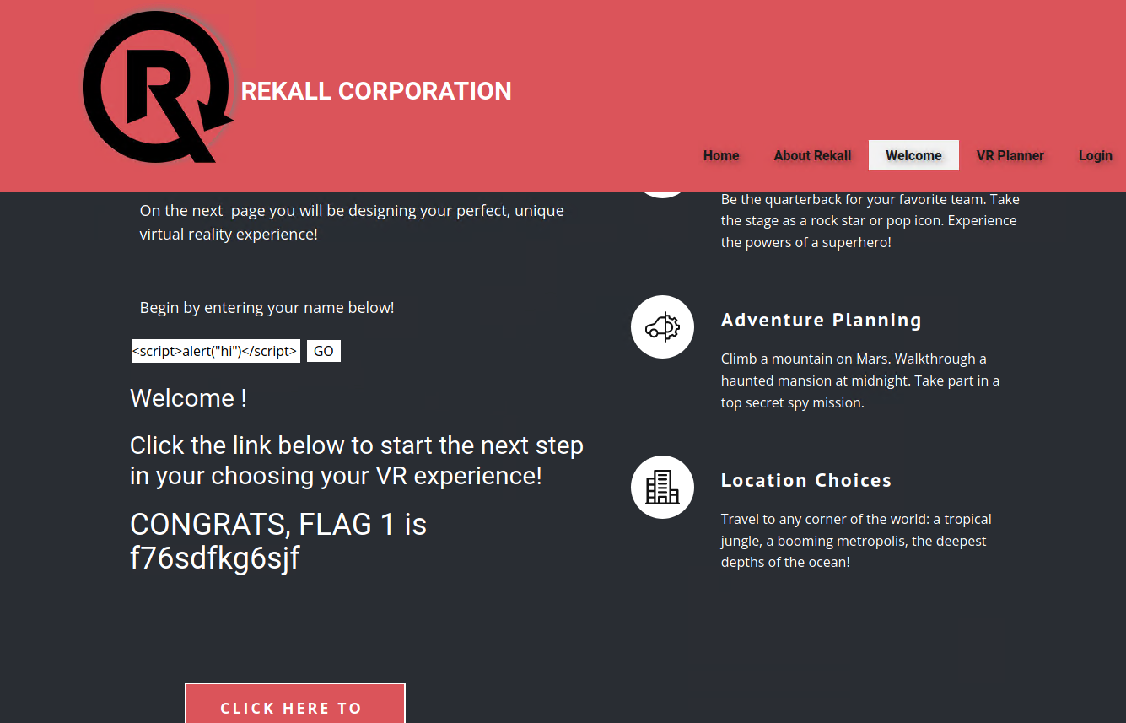

Figure 1: Reflected XSS attack from Welcome.php



Figure 2: Reflected XSS attack from Memory-Planner.php

1. **Stored XSS attack**

Figure 3 is another XSS attack called stored XSS. This is where the application stored the input and embeds it into response later.

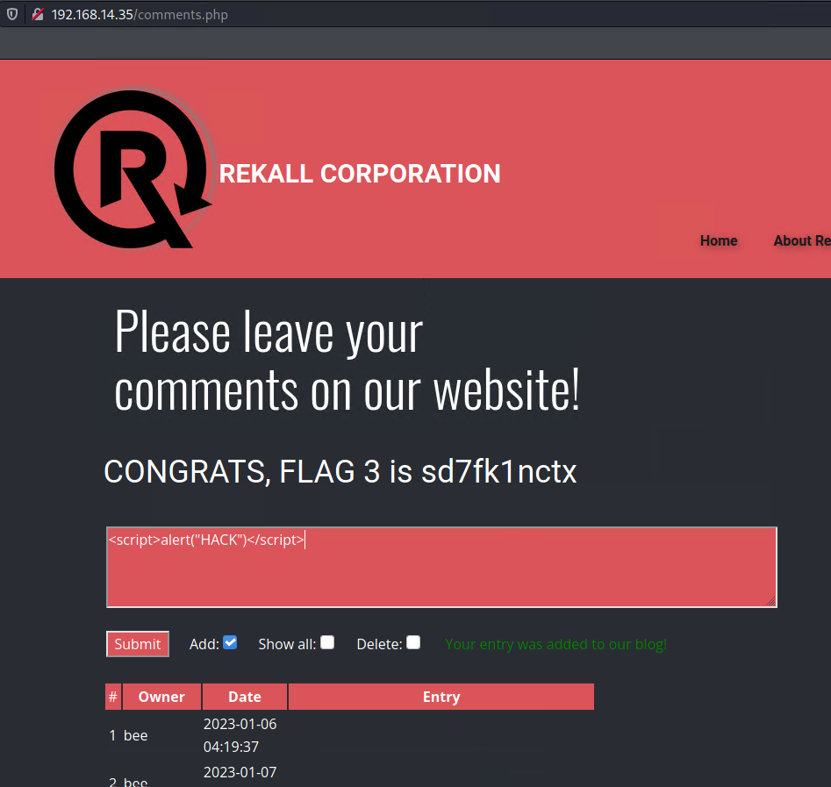

Figure 3: XSS Stored from comments.php

1. **SQL injection**

Figure 4 shows SQL injection based on 1=1 is always true and valid and will return all rows from the Users table.

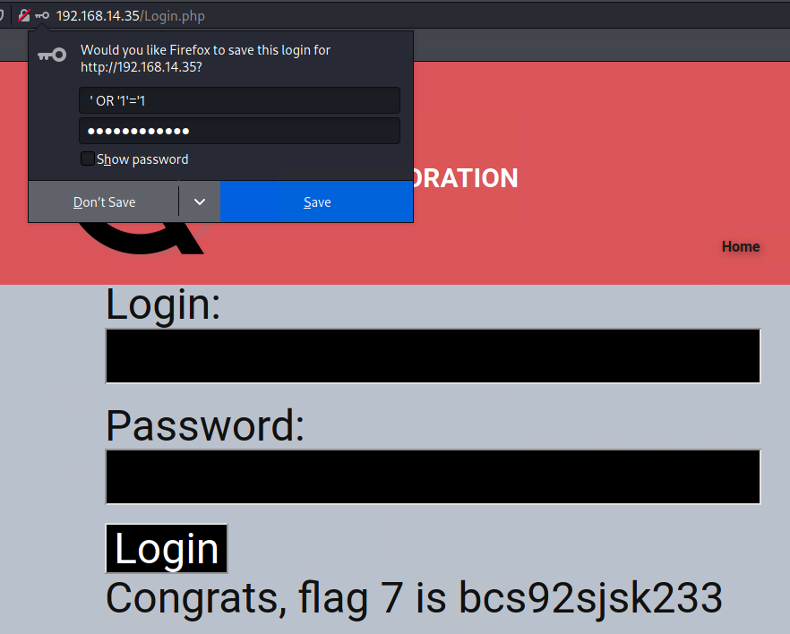

Figure 4: SQL injection from Login.php

1. **Command injection**

Figure 5 shows a command injection exploit using vendors.txt and DNS checker to gain a list of domain name, and IP address to exploit later. Figure 6 also shows a command injection exploit using vendors.txt and MX Record Checker to list mail exchange server name setup in the network.

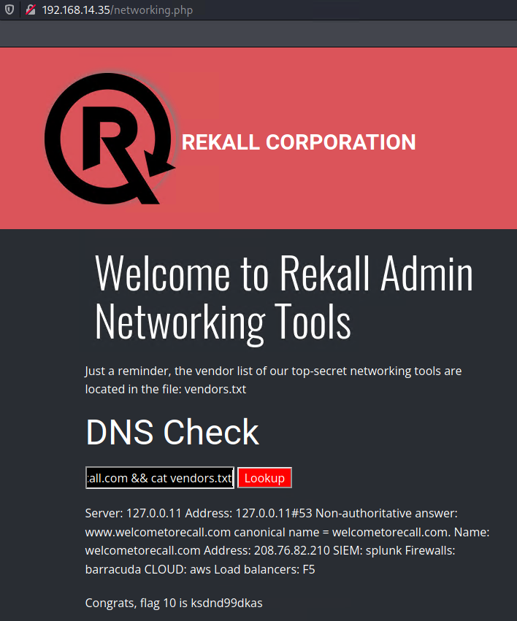

Figure 5: Command injection using DNS Checking Networking Tool

## 

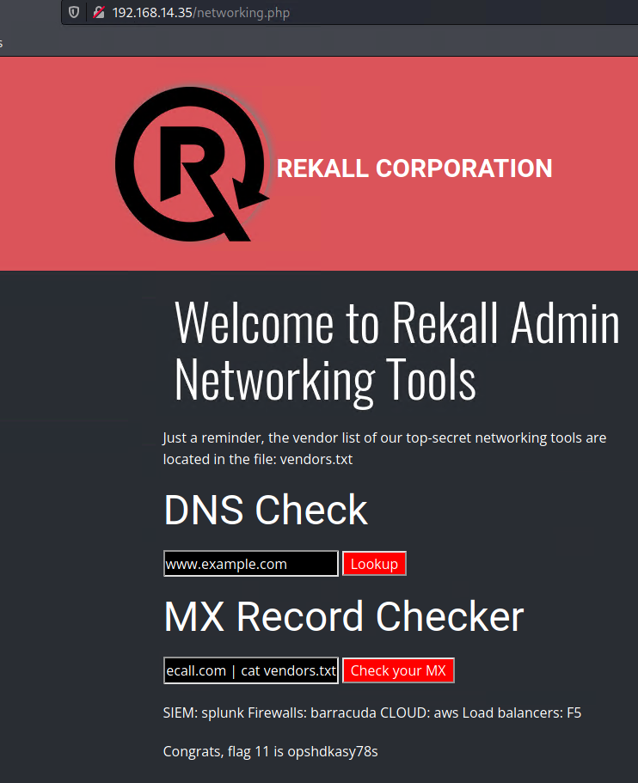

Figure 6: Command injection using MX Record Checker Networking Tool

1. **PHP Injection**

In Figure 7, PHP injection was demonstrated using a string input function *system()* to view and expose sensitive information from */etc/password* folder.

## 

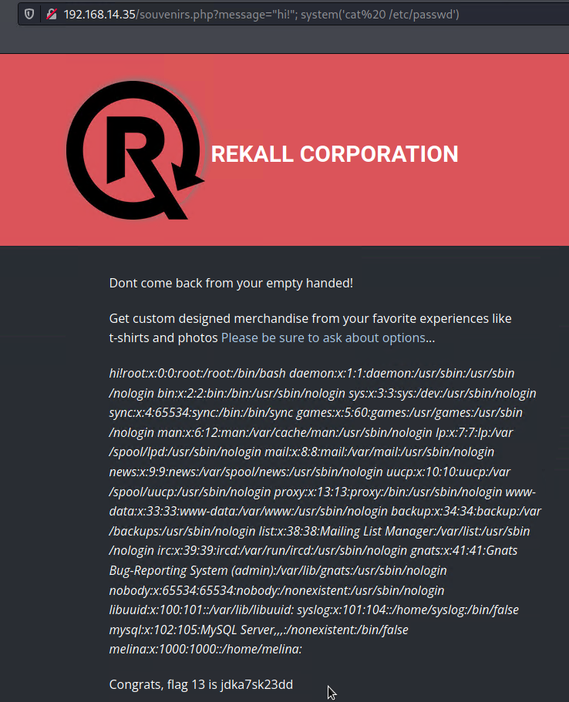

Figure 7: PHP injection

1. **Sensitive Data Exposure Tools**
2. **Using Burp suite**

Figure 8 uses Burp Suite tool to view HTTP host header. It specifies domain name that the client wants to access. It also gives information of the back-end component of the client it communicates with.

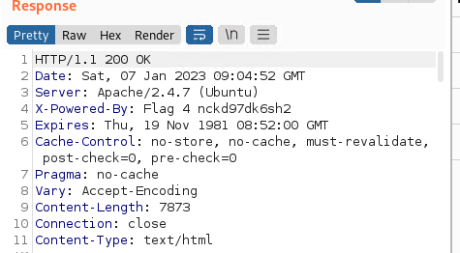

Figure 8: Burp Suite Information for HTTP response header

1. **Using HTML webpage code**

Figure 9 is a snippet of the HTML code revealing Admin credentials, username and password are exposed. Figure 10 shows the successful Admin login using the exposed sensitive data information from Figure 9.

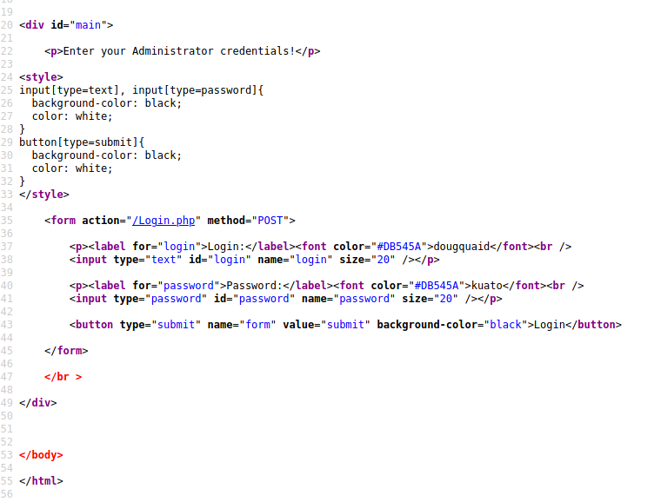

Figure 9: HTML code for Login.php

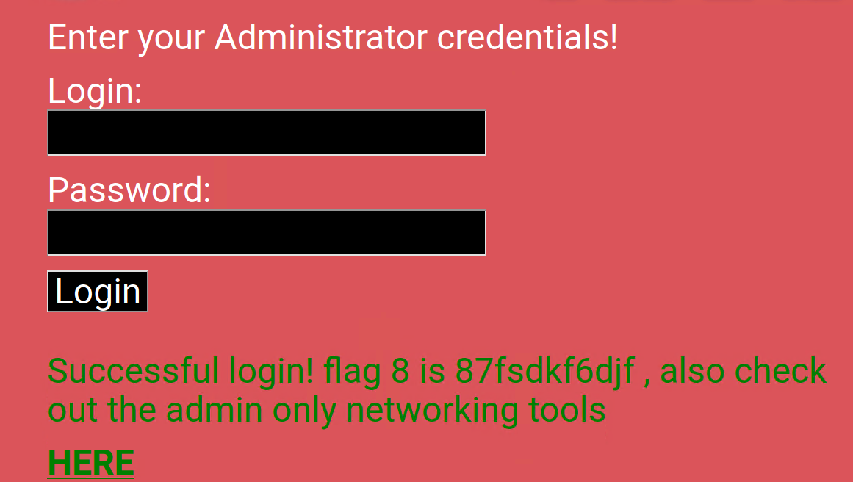

Figure 10: Successful Admin Login

1. **Using robots.txt**

Figure 11 shows robots.txt file that is used to manage web crawler traffic to the website. It is also used to block resource files such as unimportant image, script, or style files. This text file exposes web applications that are available to be exploited such as *souvenirs.php*.

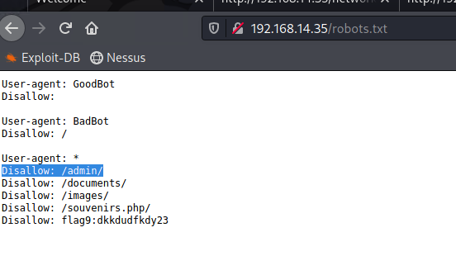

Figure 11: robots.txt sensitive data information exposure

1. **Back-end component vulnerabilities**
2. **Local File Inclusion**

Figures 12 and 14 are the files uploaded to the website to demonstrate Local File Inclusion vulnerability. Figures 13 and 15 shows a successful upload of the files in Memory-Planner.php. The file uploaded could contain PHP wrappers, wherein the functionality added to the original code provides access to a local file system to help identify sensitive information including credentials.

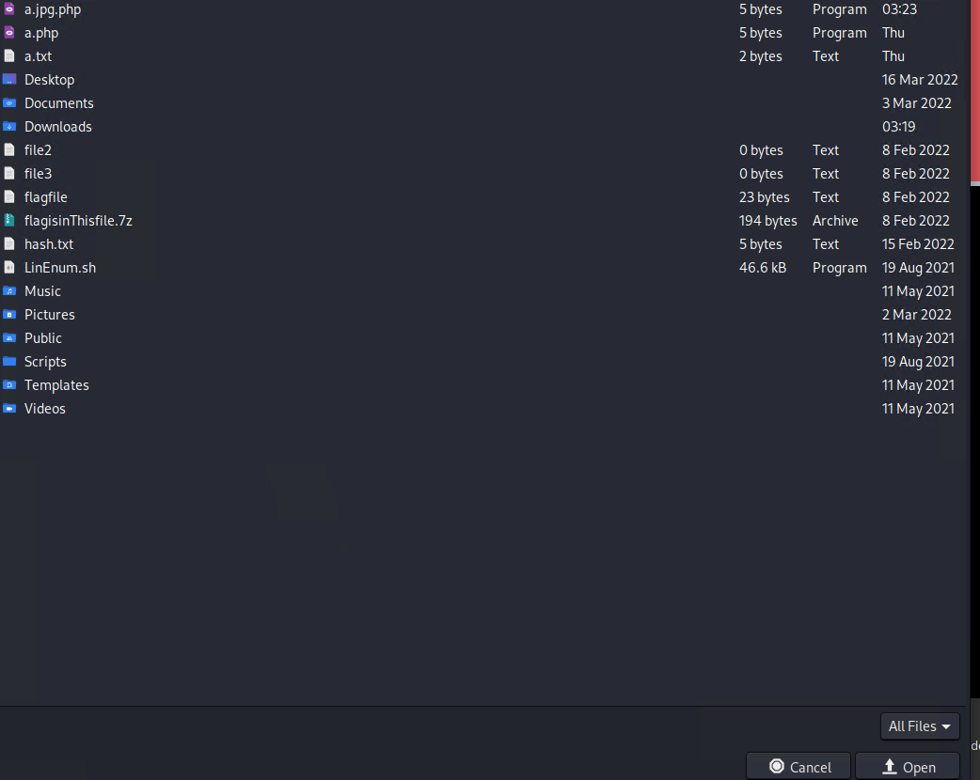

Figure 12: a.php file uploaded to Memory-Planner.php

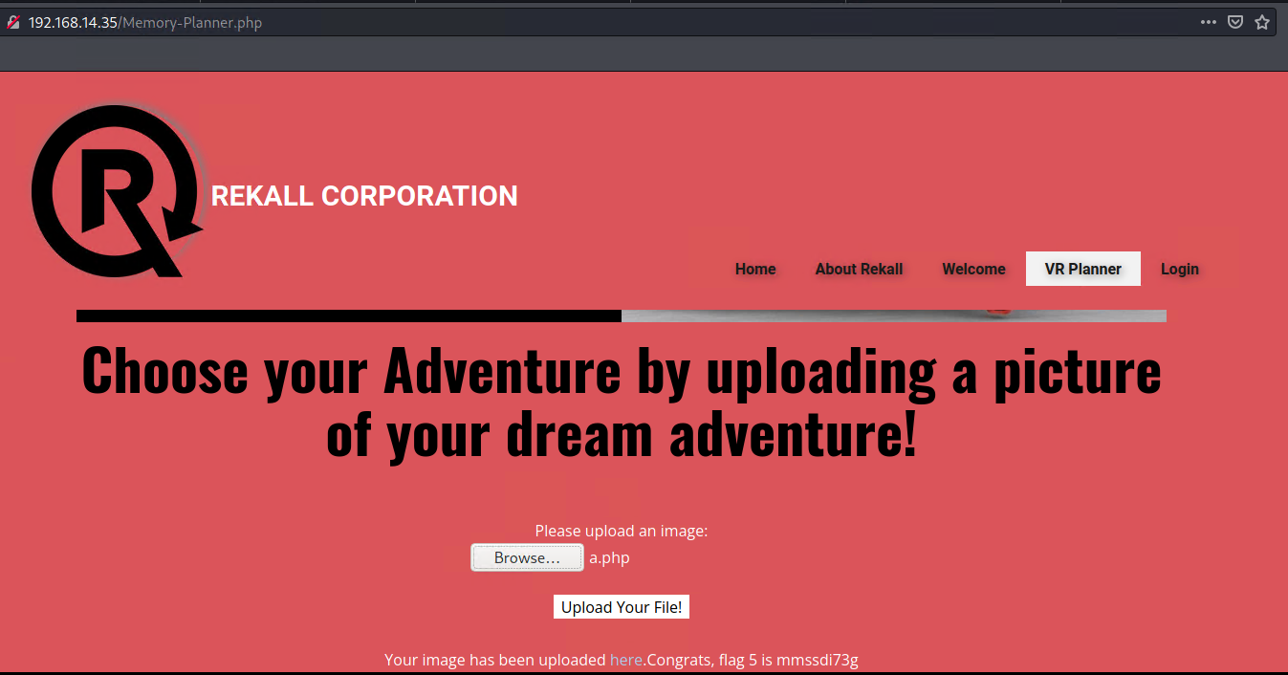

Figure 13: Successful upload of a.php file



Figure 14: a.jpg.php file uploaded to Memory-Planner.php

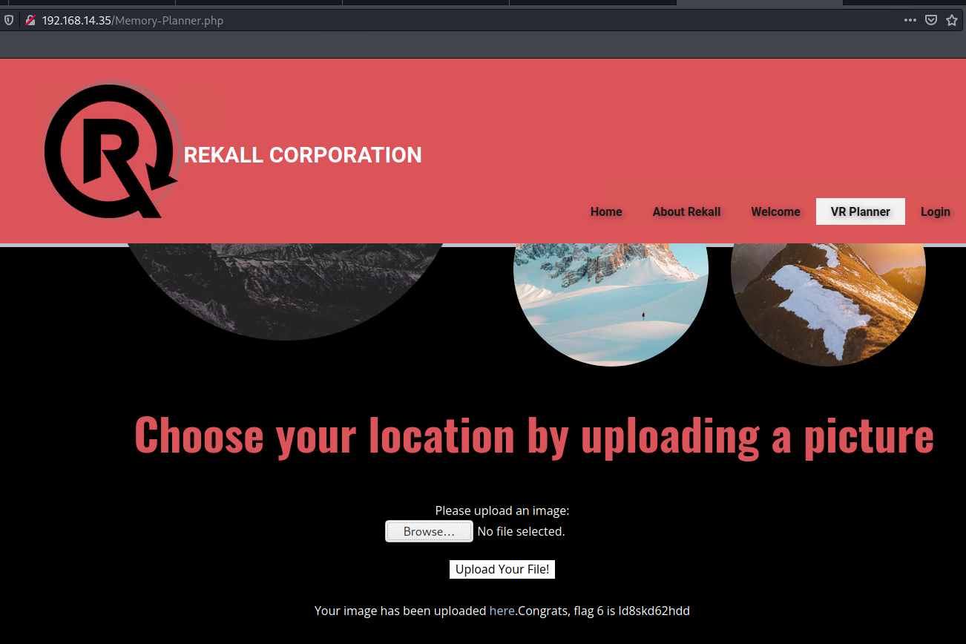

Figure 15: Successful upload of a.jpg.php file

1. **Directory traversal**

Figure 16 shows the file directories available within the website using Code Injection attack. Meanwhile, Figure 17 is successfully demonstrating Directory traversal attack using the different folders found in Figure 16.

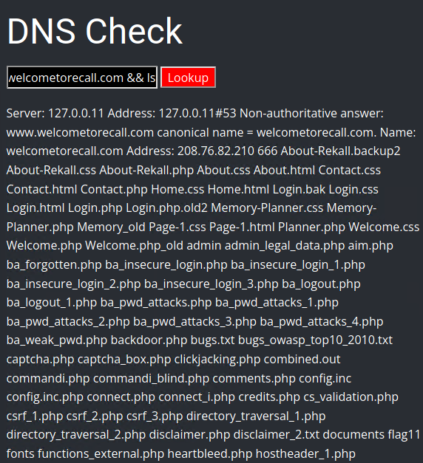

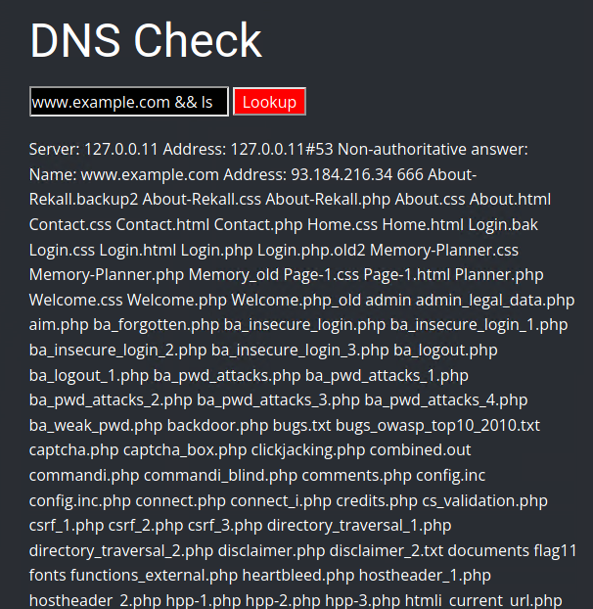

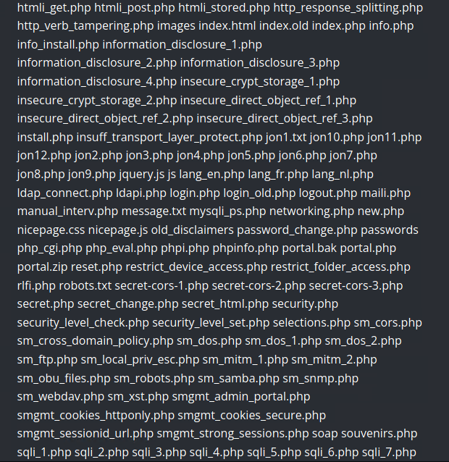

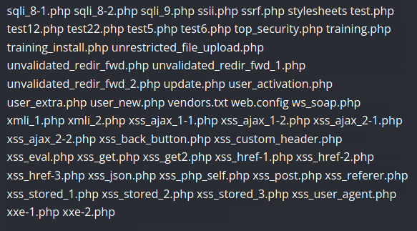

Figure 16: Command Injection File Directories

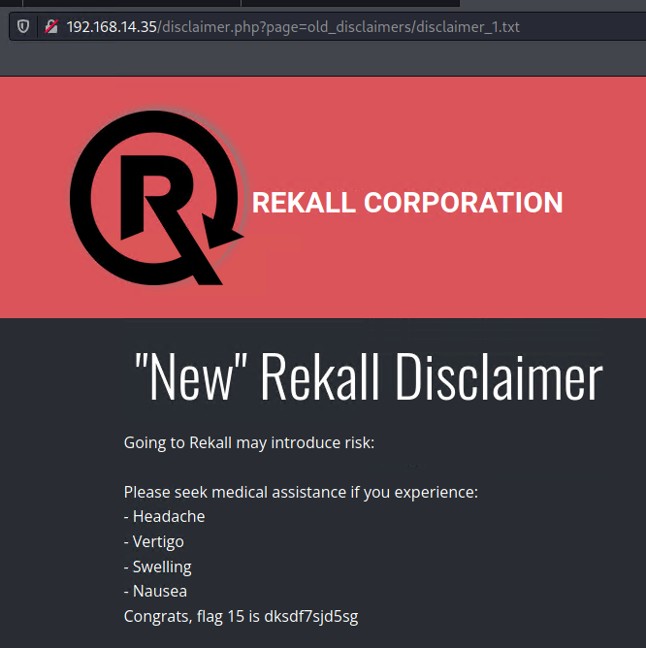

Figure 17: Successful Directory Traversal Attack

1. **Authentication vulnerabilities**
2. **Brute force attack**

In Figure 18, using command injection attack, it shows sensitive information from */etc/passwd* folder. This folder contains usernames and passwords. Using this information, Figure 19 shows a successful login to the website.

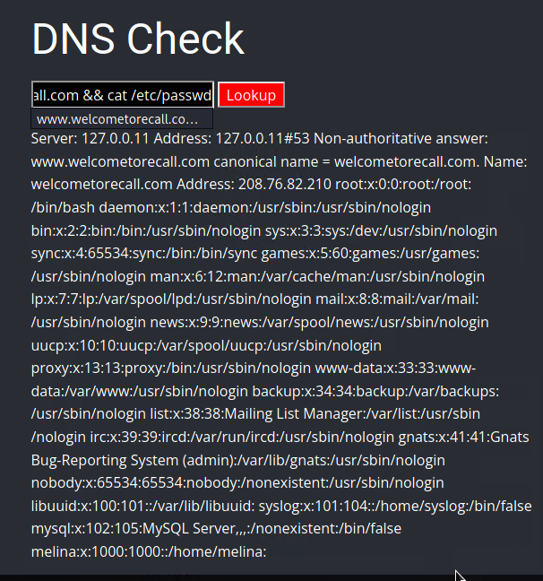

Figure 18: Command Injection attack password list

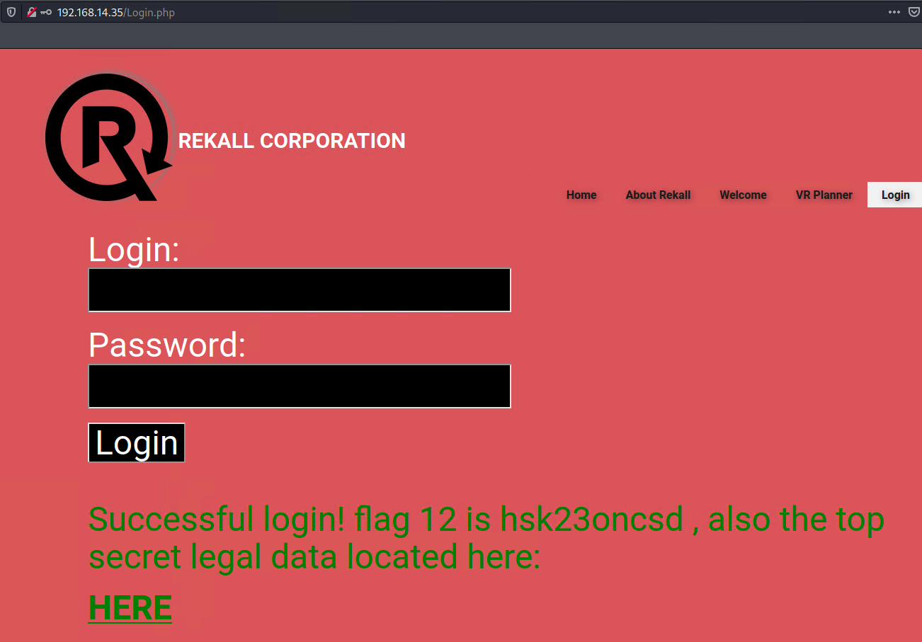

Figure 19: Successful Brute Force attack login

1. **Session management**

Figure 20 shows a successful Session management attack using the tool Burp Suite to gain access to Legal Restricted Documents webpage.

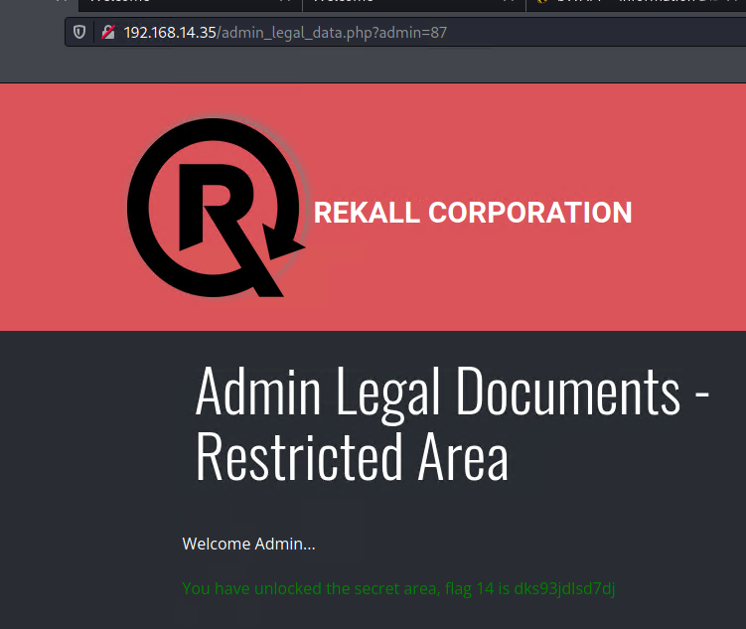

Figure 20: Session Management attack

1. **Linux Servers Vulnerabilities**

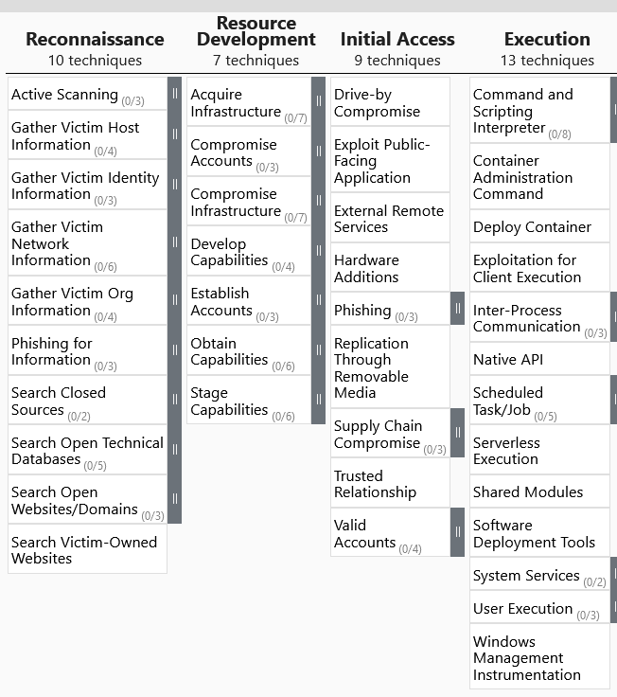

Figure 21: MITRE ATT&CK Matrix

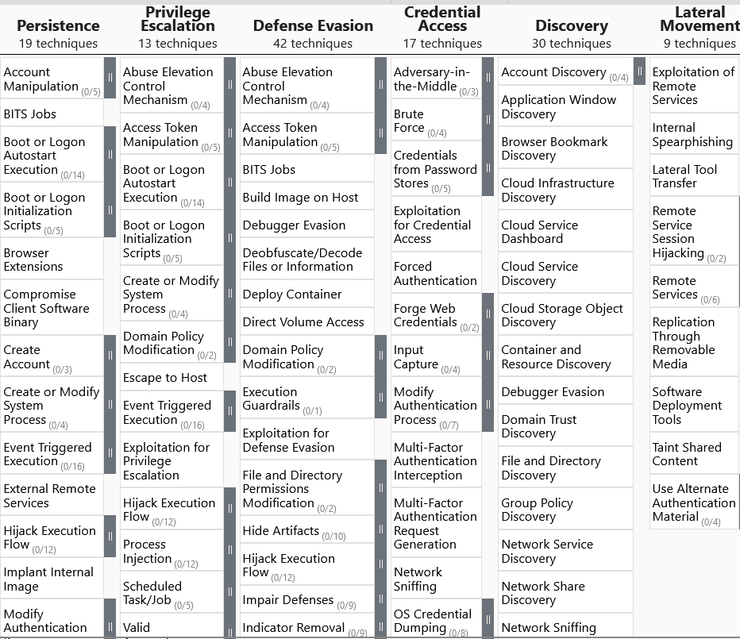

Figure 21: MITRE ATT&CK Matrix

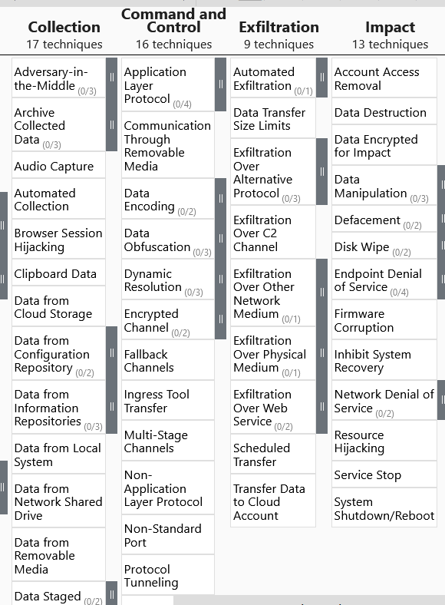

Figure 21: MITRE ATT&CK Matrix

1. **Reconnaissance**

Figure 22 shows the available information for totalrekall.xyz open for the public to view such as the Organization’s information: name, address, email, phone, and domain servers. Appendix A shows more information available. Figure 23 shows name servers and IP address for totalrekall.xyz. Figure 24 shows Certificate information for totalrekall.xyz. Figures 25 and 26 are nmap scans to map out the network’s open ports. The main difference between the two nmap scans, is that one is an aggressive scan showing OS, version, script scanning and tracerroute. Figure 27 is a Nessus scan showing the vulnerability found in the network for Drupal2 and suggested solution to solve the vulnerability.

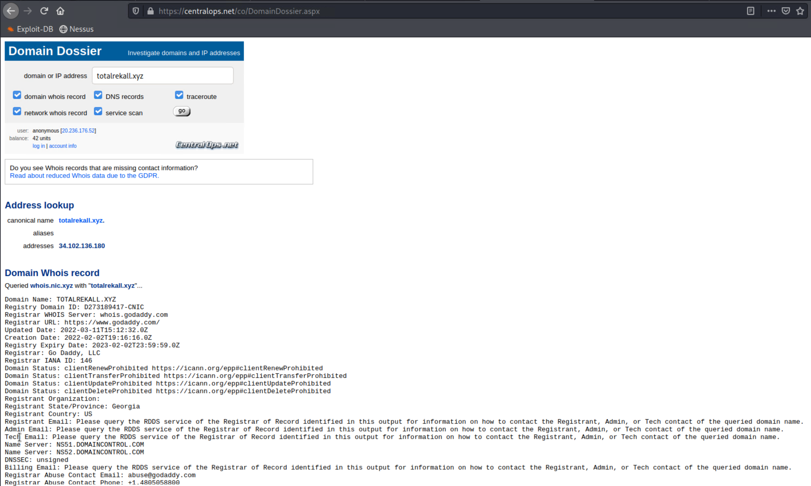

Figure 22: Domain Dossier Open-source information

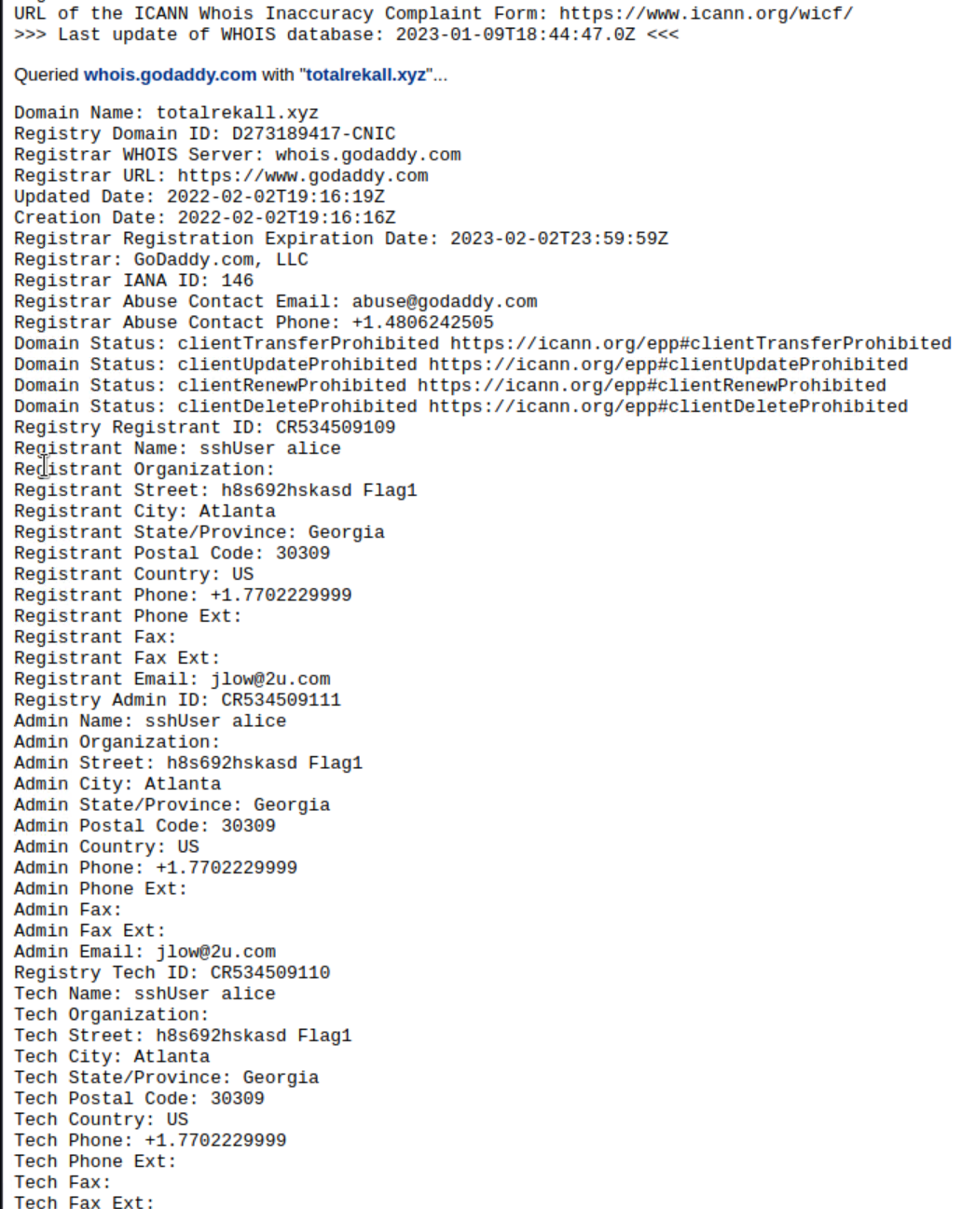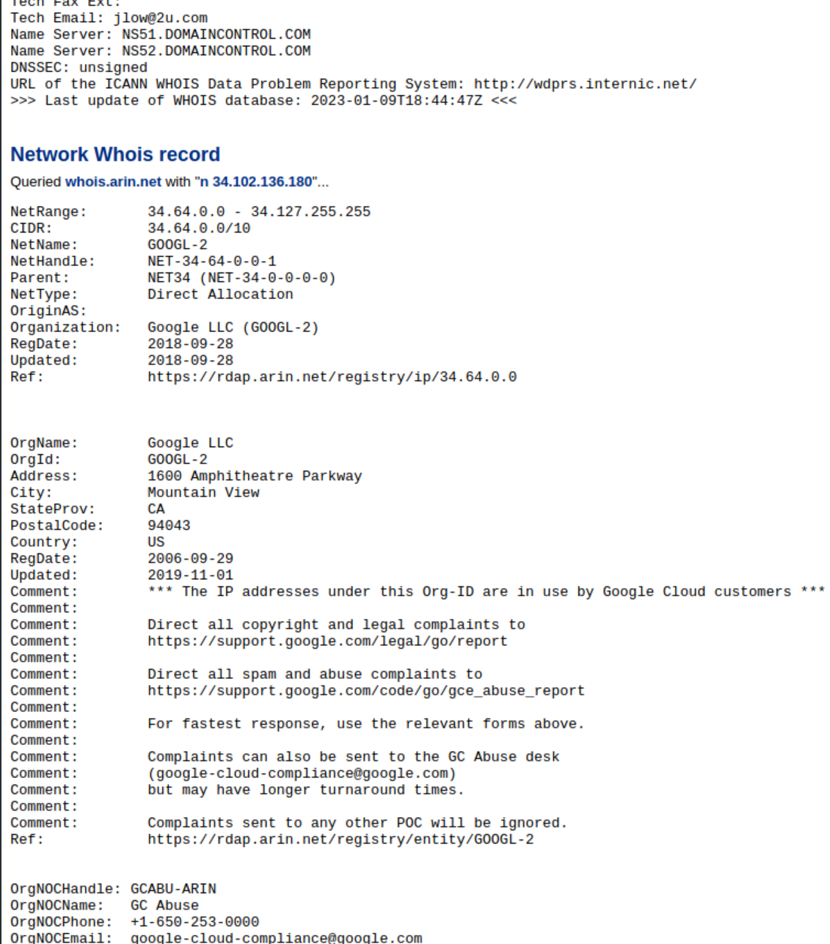

Figure 22: Domain Dossier Open-source information

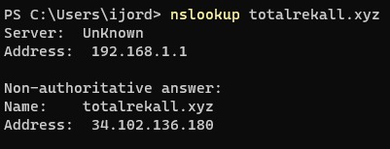

Figure 23: DNS information for totalrekall.xyz

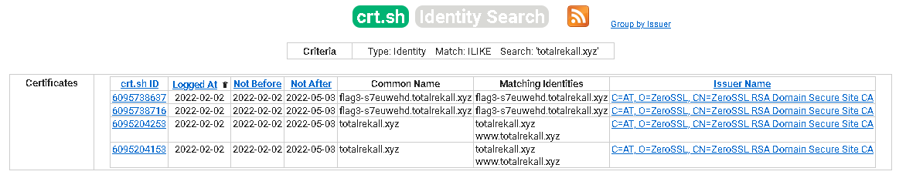

Figure 24: Certificate information for totalrekall.xyz

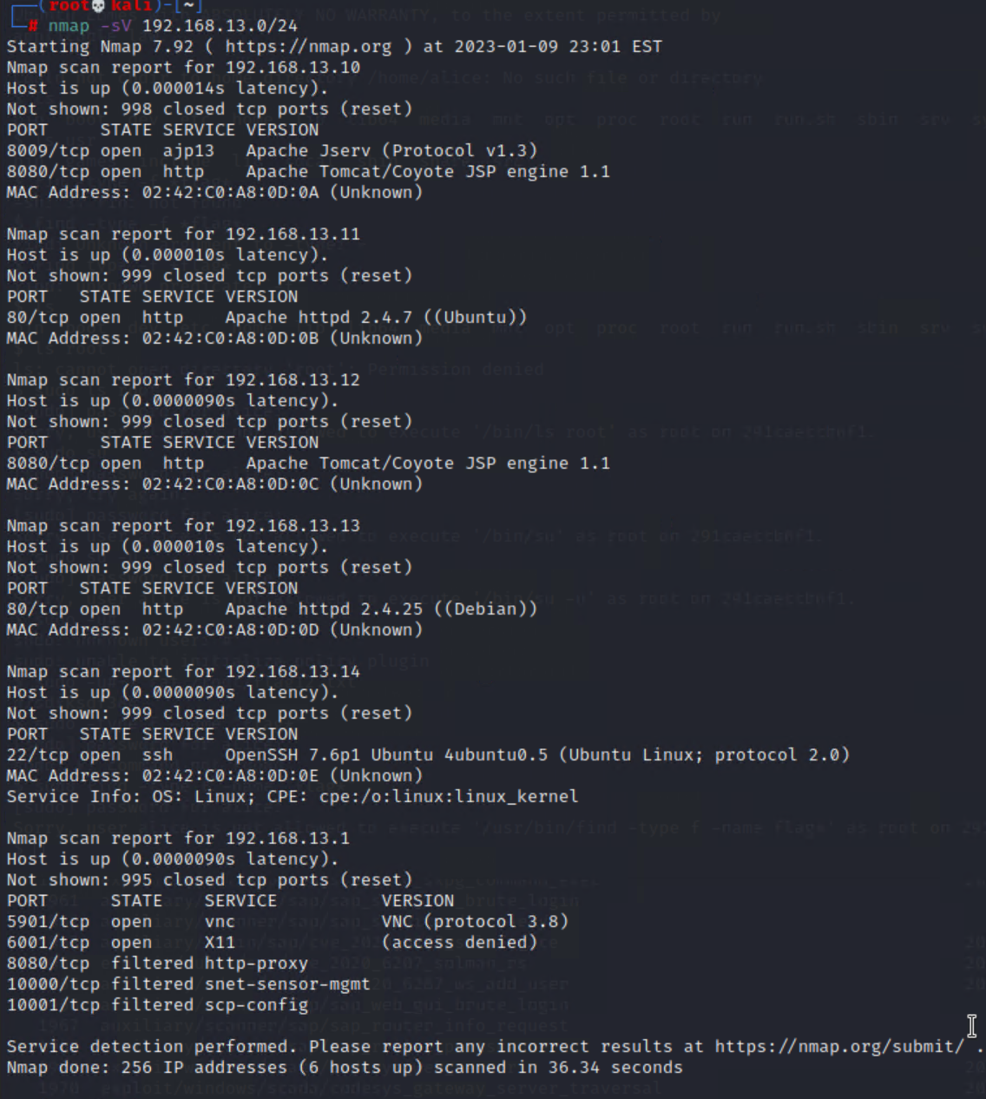

Figure 25: nmap scan for 192.168.13.0/24

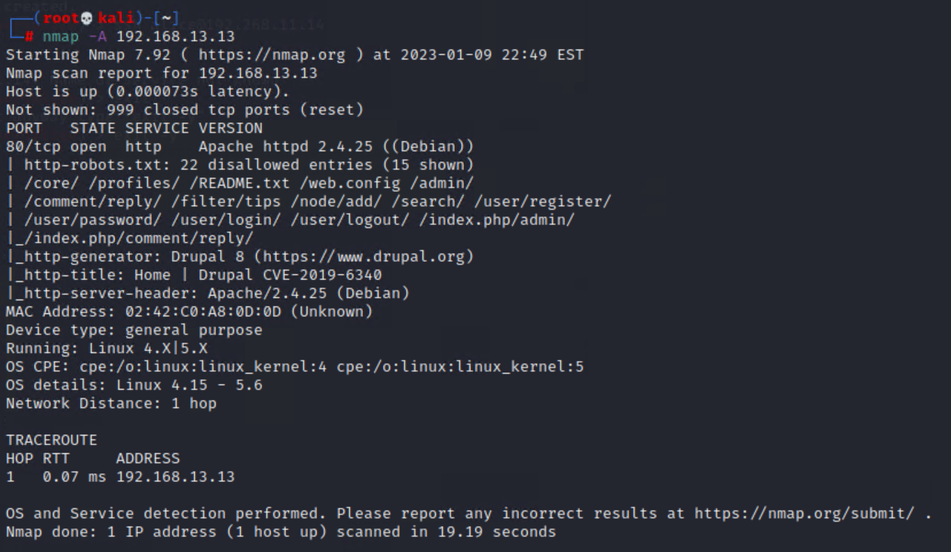

Figure 26: Aggressive nmap scan for 192.168.13.13

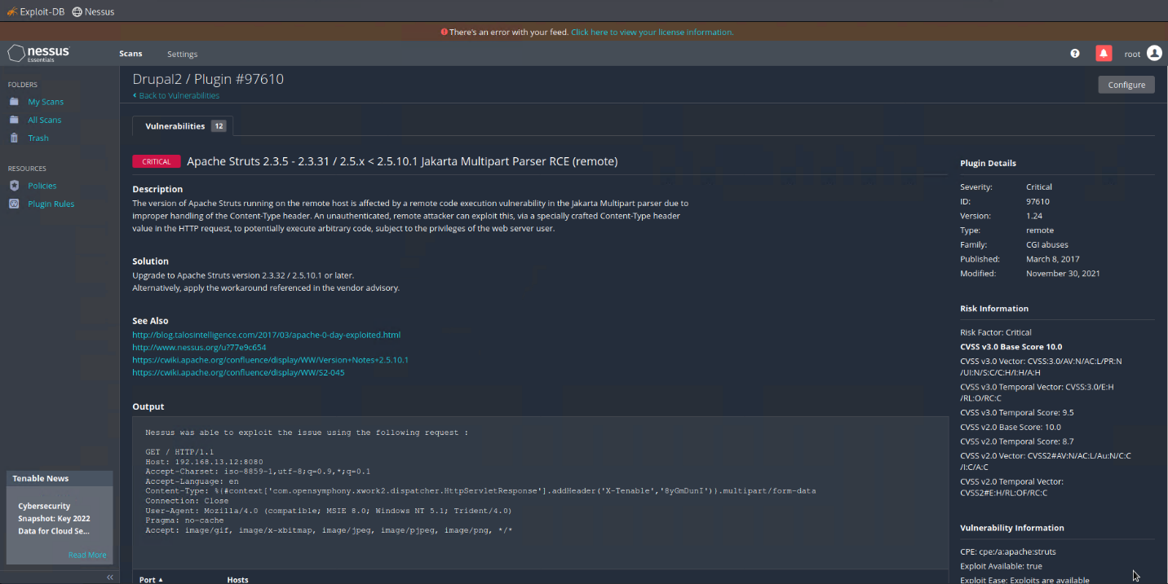

Figure 27: Nessus scanner vulnerability

1. **Exploit Vulnerabilities**
2. Apache Tomcat Remote Code Execution (RCE) Vulnerability (CVE-2017-12617)

Apache Tomcat RCE vulnerability affects systems that have the HTTP PUT method enabled, it could be exploited by attackers to upload malicious JSP files to target server using specially crafted requests. Once the file is uploaded, the code contains requests that execute files. Figure 28 shows the method used: first search for the exploit Tomcat and second, setup the options to successfully run the exploit. Figure 29 shows successfully running the exploit for Remote code execution vulnerability and successfully accessed the root of one of the machines discovered during the reconnaissance phase.

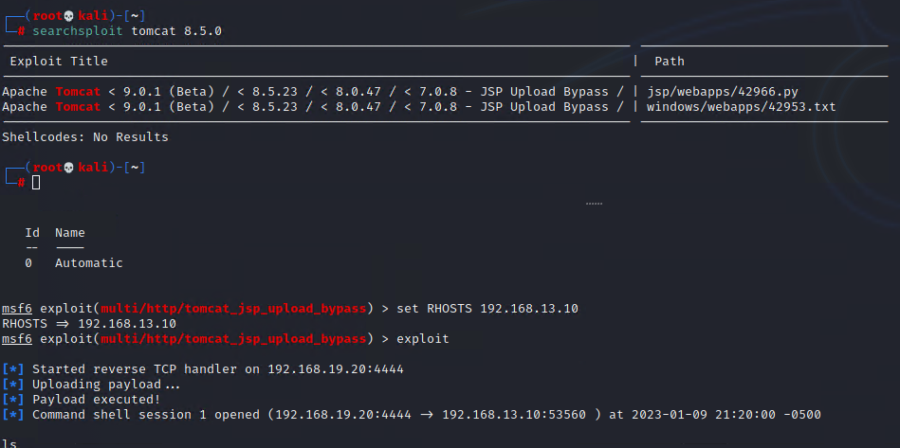

Figure 28: Searchsploit for Tomcat and exploit used and setup

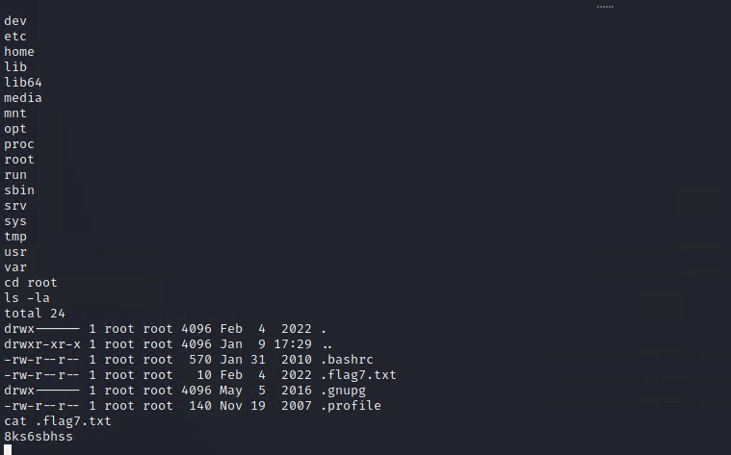

Figure 29: Shell command root exploit for 192.168.13.10

1. ShellShock Vulnerability (CVE-2014-6271)

ShellShock vulnerability allows remote attackers to execute arbitrary code via a crafted environment using vectors involving ForceCommand features in OpenSSH ssh, the mod_cgi and mod_cgid modules in Apache HTTP server. The script executes unspecified DHCP clients and other situations wherein the environment occurs across a privilege boundary from Bash execution or ShellShock. Figure 30 shows the setup for exploiting the vulnerability. Figure 31 shows that the exploit was successfully completed and gain access to sensitive folders: */etc/sudoers* and */etc/passwd*.

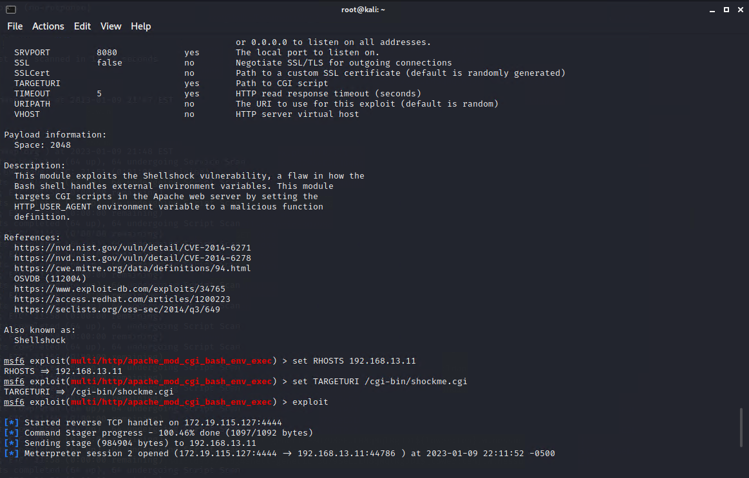

Figure 30: ShellShock exploit options setup

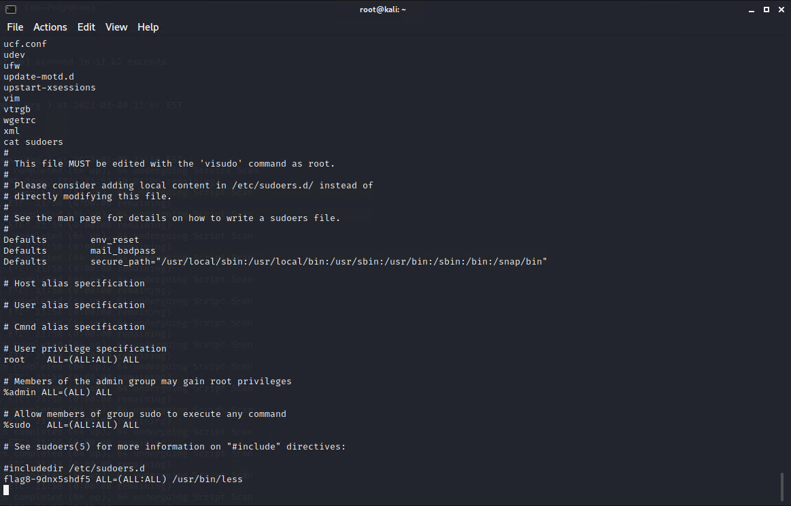

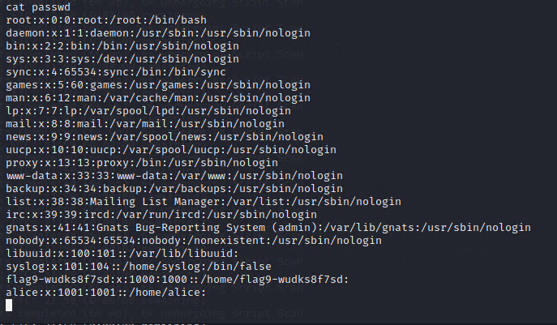

Figure 31: Shell command root exploit for 192.168.13.11

1. Struts vulnerability - CVE-2017-5638

Struts is vulnerable to remote command injection attacks through incorrectly parsing an attacker’s invalid Content-Type HTTP header. The vulnerability allows these commands to be executed under the privileges of the web server. The exploit can be further facilitated by its ability to receive information back from the server on the status and output of the commands that are executed by the web server. The exploit used for Struts vulnerability is *exploit/multi/http/struts2_content_type* and Figure 32 shows the successful access of the root.

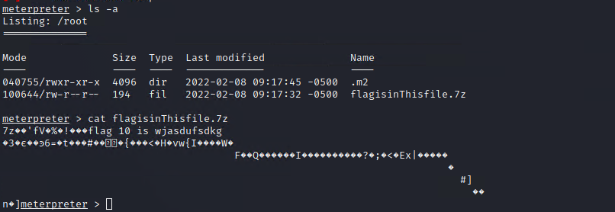

Figure 32: Shell command root exploit for 192.168.13.12

1. Drupal Core Remote Code Execution Vulnerability- CVE-2019-6340

Drupal’s vulnerability is an unauthenticated remote code execution flaw in Drupal 8’s REST API module when it is enabled. The exploit used is *exploit/unix/webapp/drupal_restws_unserialize* and Figure 33 shows that a remote shell was successfully obtained and user privileges is attained of the compromised web application.

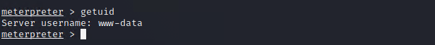

Figure 33: Shell command exploit for 192.168.13.13

1. Sudo Vulnerability allows Bypass of User Restrictions - CVE-2019-14287

Sudo version before 1.8.28 allows an attacker with access to a “Run as ALL” sudoers account to bypass certain policy blacklists and session PAM modules. This can cause incorrect logging by invoking sudo with a crafted user ID. Figure 34 shows a summary of the Nessus scan about CVE-2019-14287. Figure 35 shows the successful exploit of the vulnerability wherein the user was changed to root and was able to access sensitive root files.

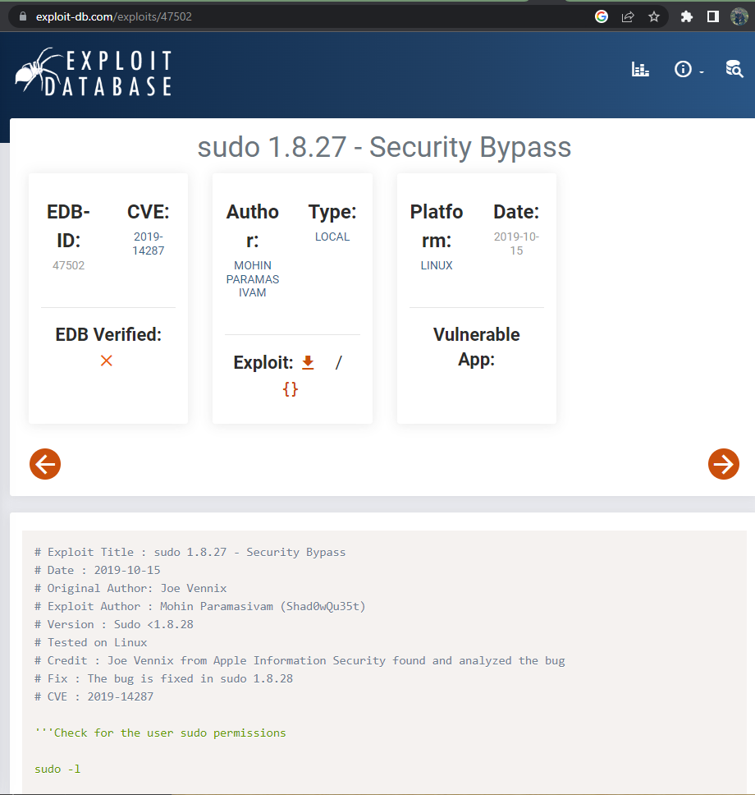

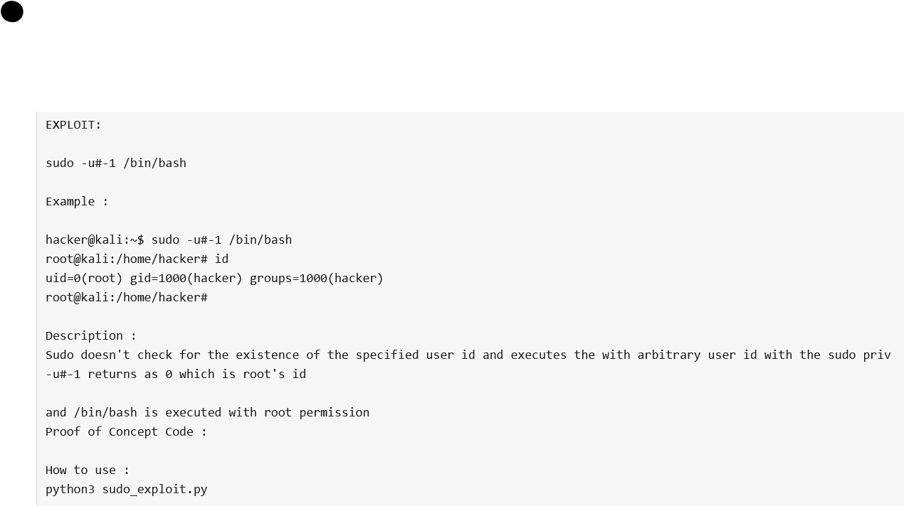

Figure 34: Nessus scan result for CVE-2019-14287

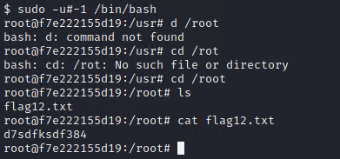

Figure 35: Shell command exploit for 192.168.13.14

1. **Windows Servers**
2. **Open-Source Intelligence (OSINT)**

Figure 36 is an open-source information found from Totakrekall’s Github showing credentials for trivera. This information is then copied to a text file and used by the *john* application to crack the hash. Figure 37 shows successfully cracking the hash and gaining the credentials to login to one of the servers.

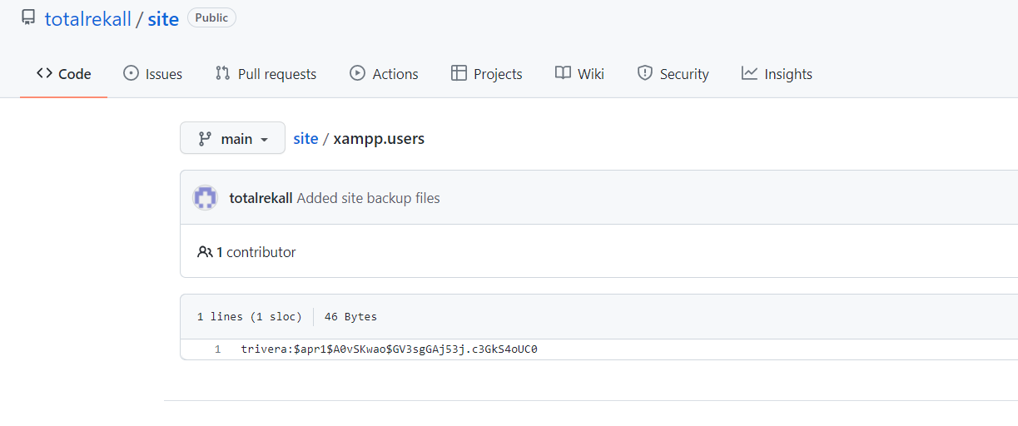

Figure 36: Github site with credentials open to the public

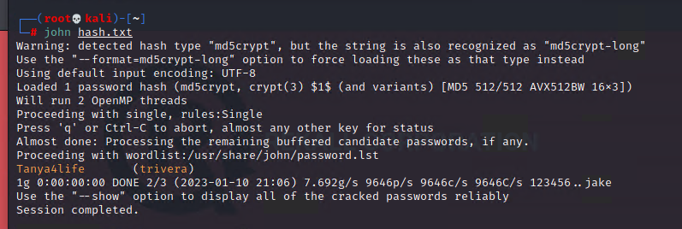

Figure 37: Successful *john* cracked hash

1. **Active Scanning**
   1. **Windows 10 HTTP Enumeration**

As part of reconnaissance, port scanning phase of the penetration phase using Nmap tool. Figure 38 shows that there are two Windows server, one WinDC01 and the other Windows 10. Figure 39 shows the login page into the Windows server and Figure 40 shows a successful login to the server using the credentials found previously.

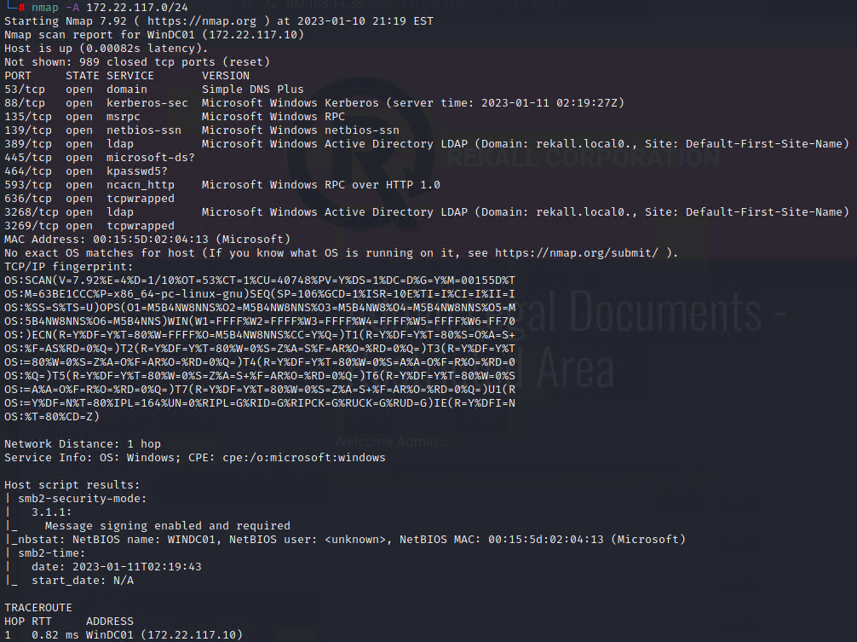

Figure 38: Aggressive NMAP scans for 172.22.117.0/24

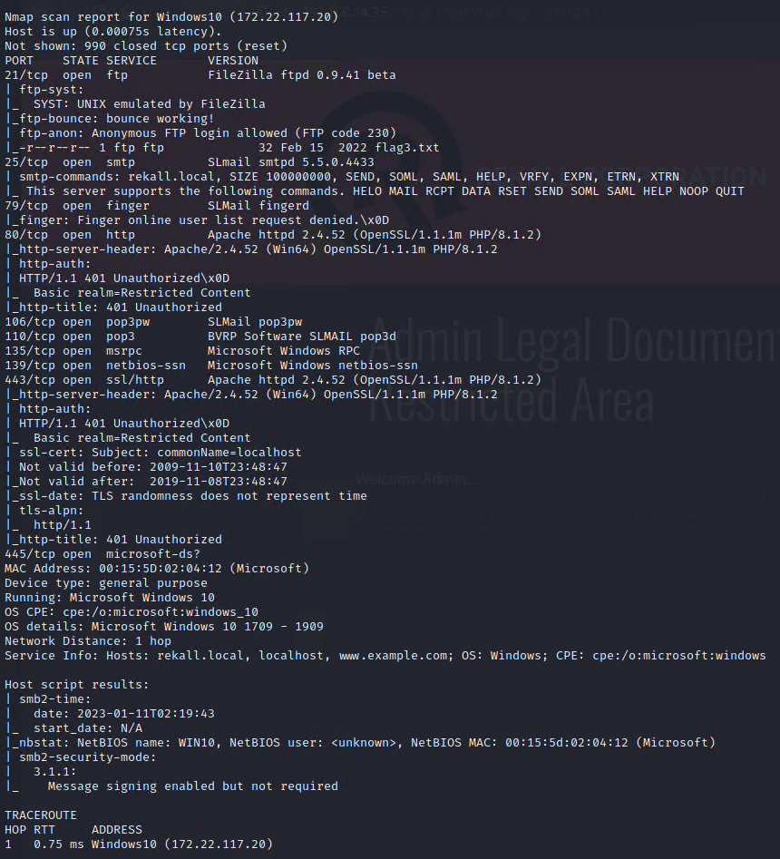

Figure 38: Aggressive NMAP scans for 172.22.117.0/24

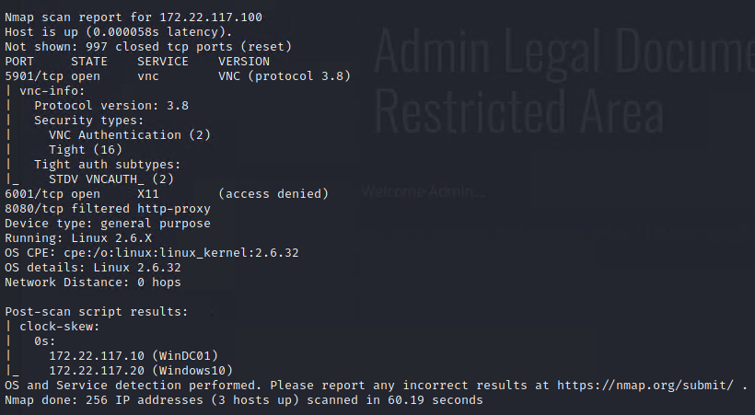

Figure 38: Aggressive NMAP scans for 172.22.117.0/24

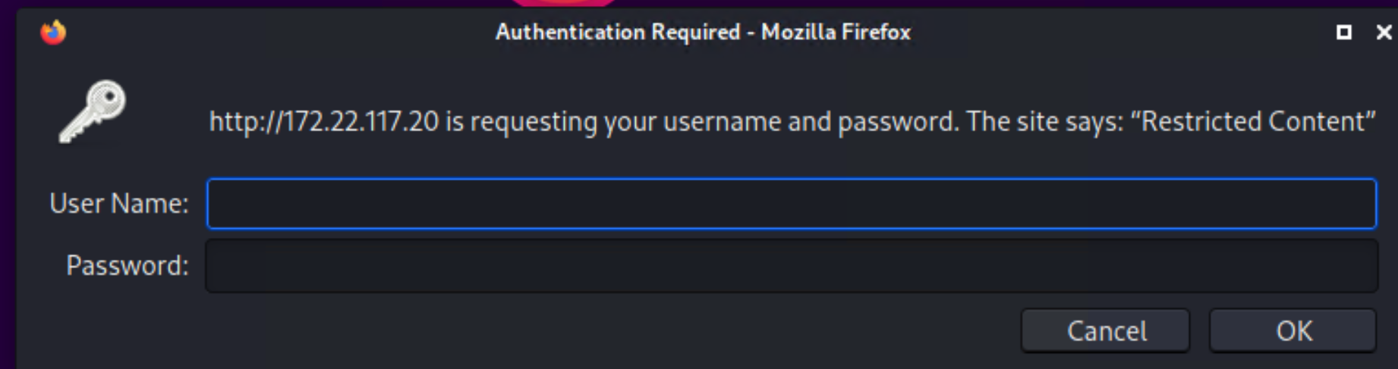

Figure 39: Login page for 172.22.117.20

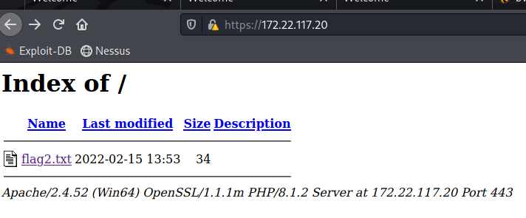

Figure 40: Successful login to the server

1. **Windows 10 FTP Enumeration**

FTP is a network protocol used to transfer files from a server to a client over a network. Figure 41 shows that the FTP server doesn’t have any credentials setup, which allowed for a successfully gaining connection and transfer of files over the network.

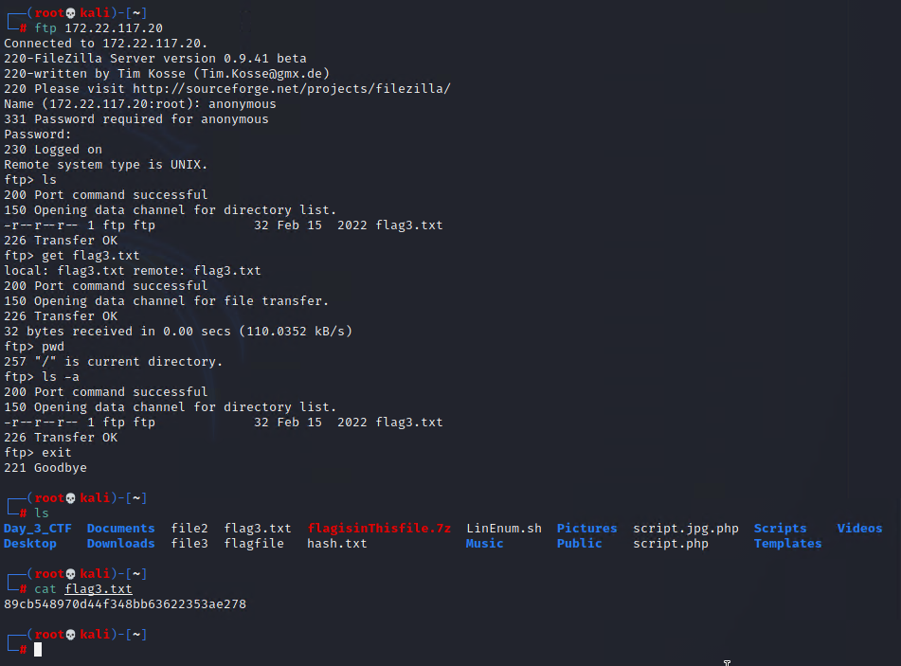

Figure 41: FTP Enumeration for 172.22.117.20

1. **Metasploit Exploit for Windows 10 Mail server**

The Metasploit tool was used to exploit the SLmail server and Figure 42 shows that the exploit used was *exploit/windows/pop3/seattlelab_pass* and the options were setup to point to the host 172.22.11.20 and upon setup, run the exploit. Figure 43 shows successfully gaining access to the Meterpreter shell and gaining access to the files within the host.

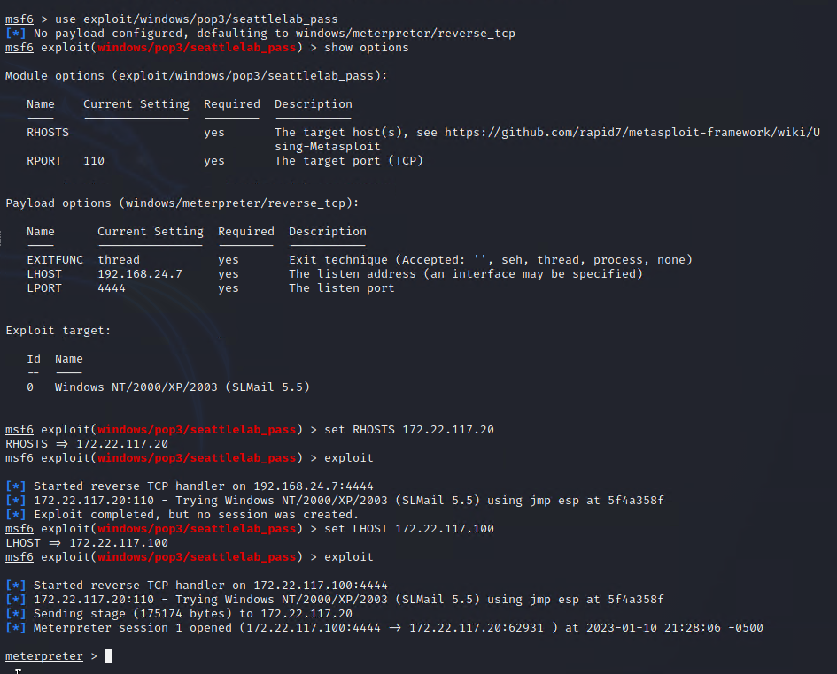

Figure 42: Slmail Metasploit module exploit

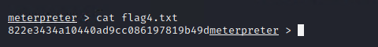

Figure 43: Successful Meterpreter shell exploit

1. **Common Scheduled Tasks Exploit**

Using the Meterpreter command shell, which was previously obtained, investigate, and find sensitive information available. Figure 44 shows the list of Scheduled tasks available in the Windows 10 host using the *schtasks /query* command.

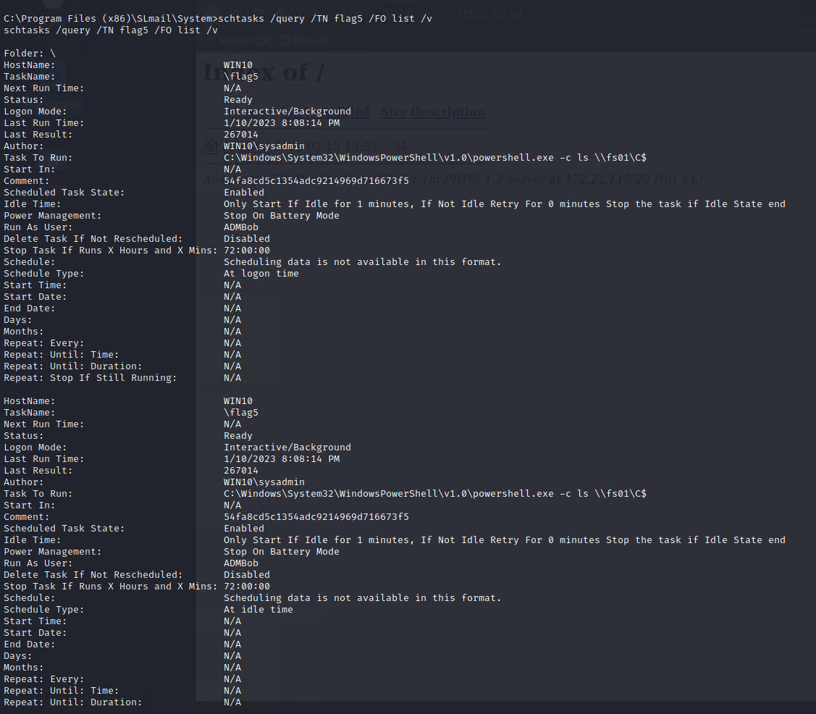

Figure 44: Common Scheduled Tasks Enumeration

1. **User Enumeration for Windows 10 Mail Server**

Load kiwi module from the Meterpreter shell and then use *lsa_dump_sam* command to list all the available users and credentials and hashes as shown in Figure 45. Using this information, the application *john* is used to crack the hash as shown in Figure 46.

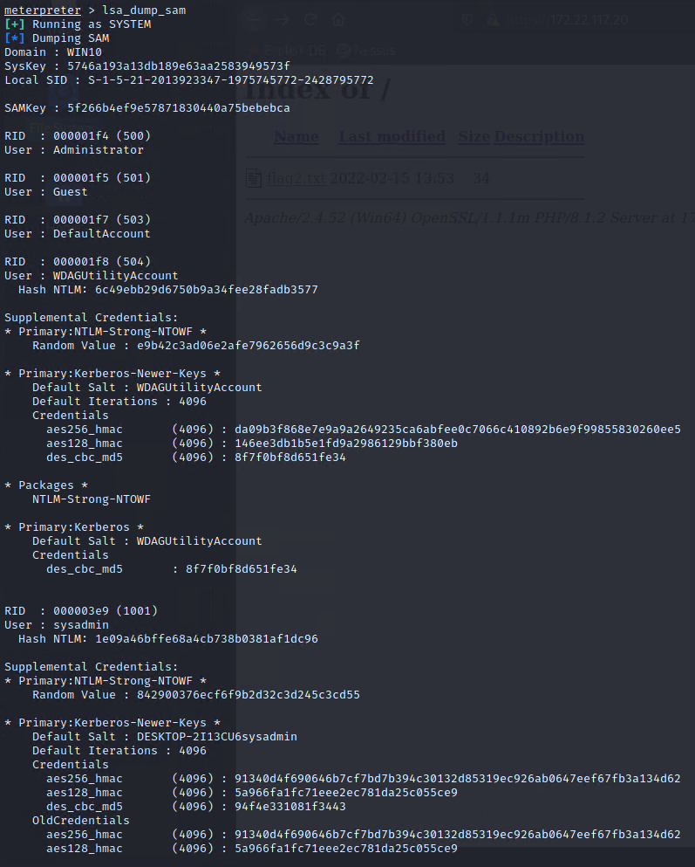

Figure 45: User Enumeration using kiwi module

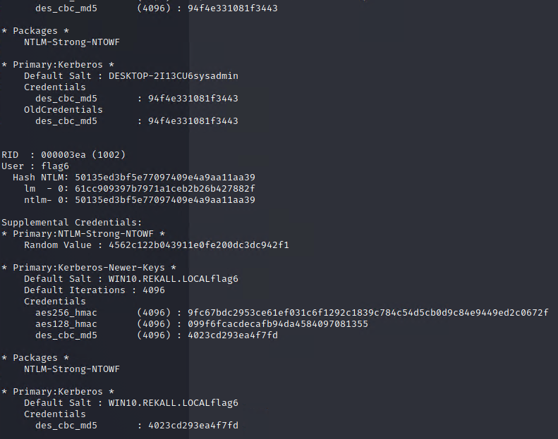

Figure 45: User Enumeration using kiwi module

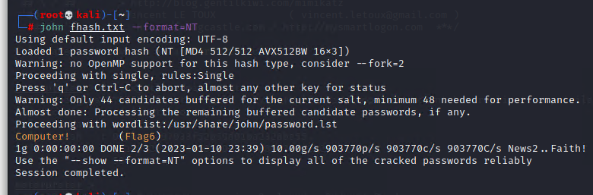

Figure 46: Credentials cracked using *john*

1. **File Enumeration for Windows 10**

Figure 47 shows an example of file enumeration to find useful files to potentially gain more information. Figure 48 demonstrates file accessed and read in the command shell.

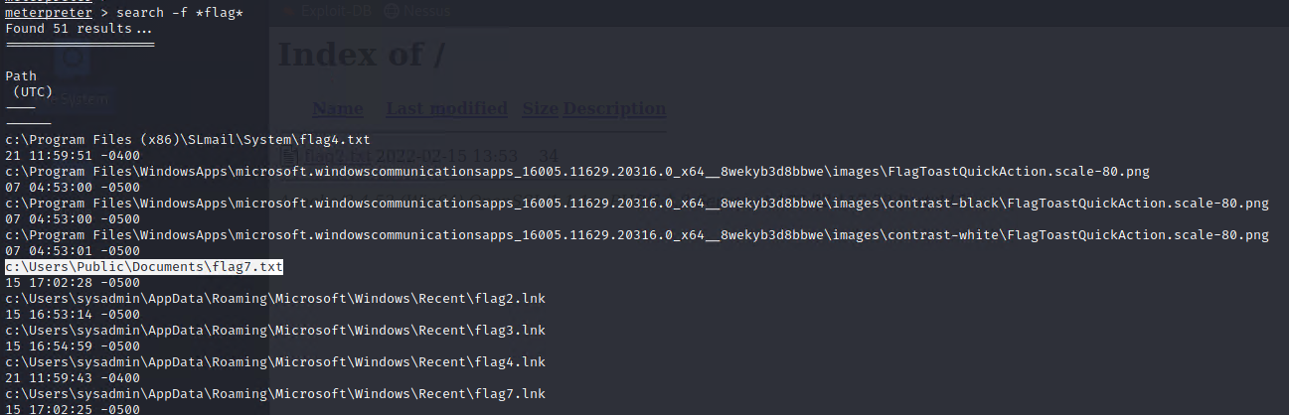

Figure 47: File Enumeration for Windows 10

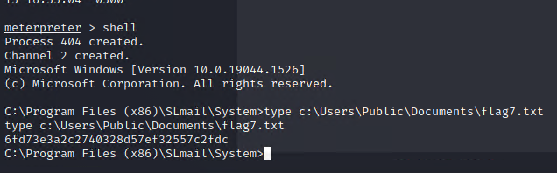

Figure 48: File access successful

1. **User Enumeration for Windows 10**

The kiwi module was loaded and *kiwi_cmd lsadump::cache* command was used to enumerate users available in this host. Figure 49 shows the user ADMBob and its corresponding hash and in Figure 50 shows the password being cracked using *john.*

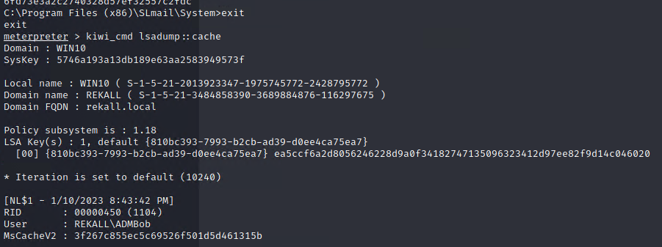

Figure 49: User Enumeration for Windows 10

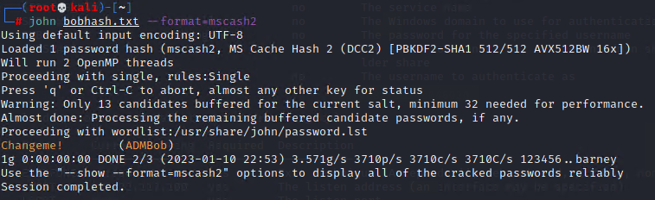

Figure 50: Credentials crack using *john*

1. **Escalating Access to WINDC01**

Figure 51 shows the Metasploit the setup for *exploit/windows/smb/psexec* to obtain a system shell command to WINDC01 machine. Figures 52, 53 and 54 are system shell successfully accessed and gives a list of all users and files that could be useful later on.

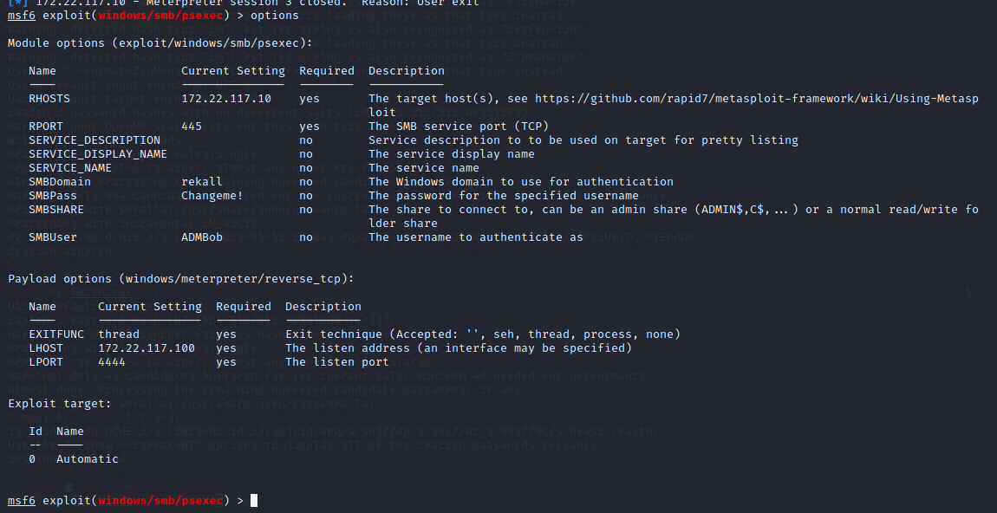

Figure 51: PsExec options setup

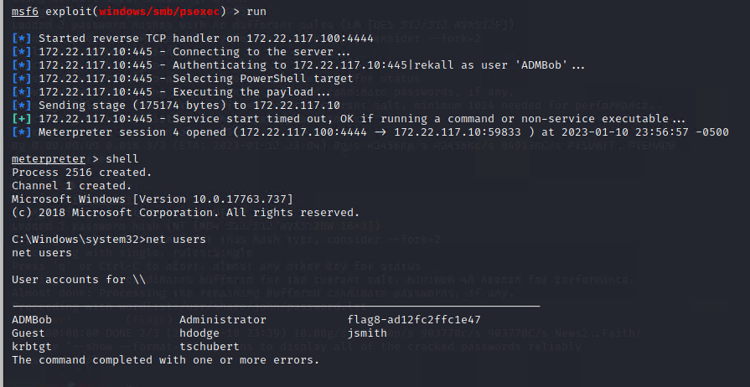

Figure 52: Exploit Meterpreter command shell

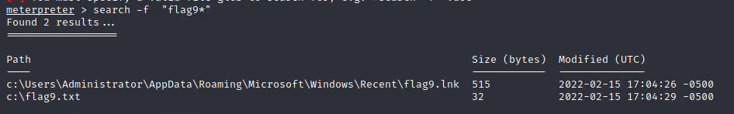

Figure 53: Meterpreter Command shell file enumeration

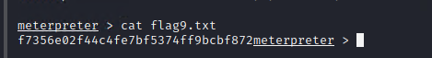

Figure 54: File access successful

1. **Compromising Admin**

Load kiwi module to run DCSync to compromise the administrator as shown in Figure 55.

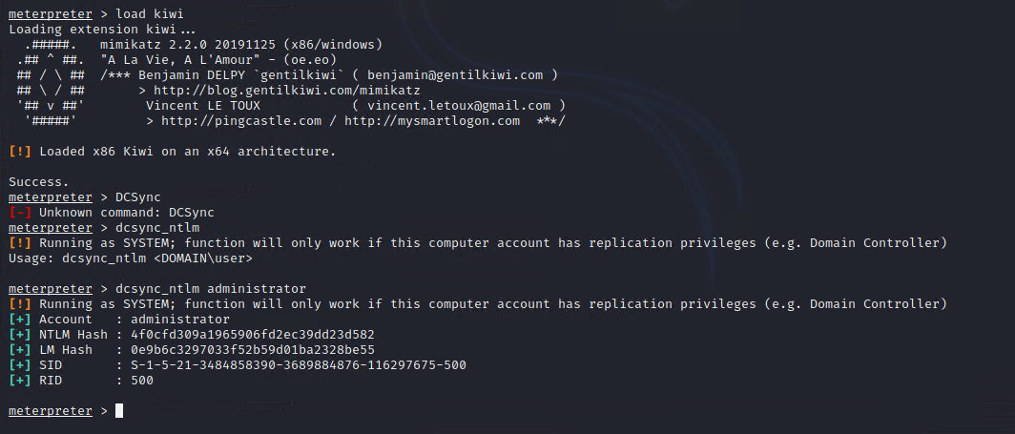

Figure 55: DCSync module to compromise the admin account

## Summary Vulnerability Overview

|  |  |
| --- | --- |
| **Vulnerability** | **Severity** |
| CVE-2017-12617 | **HIGH** |
| CVE-2014-6271 | **CRITICAL** |
| CVE-2017-5638 | **CRITICAL** |
| CVE-2019-6340 | **HIGH** |
| CVE-2019-14287 | **HIGH** |
| CVE-2003-0264 | **HIGH** |
| CVE-2004-2730 | **MEDIUM** |
|  |  |
|  |  |
|  |  |
|  |  |
|  |  |
|  |  |
|  |  |
|  |  |
|  |  |
|  |  |
|  |  |
|  |  |
|  |  |
|  |  |

The following summary tables represent an overview of the assessment findings for this penetration test:

|  |  |
| --- | --- |
| **Scan Type** | **Total** |
| Hosts | 7 |
| Ports | 26 |

|  |  |
| --- | --- |
| **Exploitation Risk** | **Total** |
| **Critical** | 2 |
| **High** | 4 |
| **Medium** | 1 |
| **Low** | 0 |

## Vulnerability Findings

|  |  |
| --- | --- |
| **Vulnerability 1** | **Findings** |
| **Title** | CVE-2014-6271 |
| **Type (Web app / Linux OS / WIndows OS)** | Linux |
| **Risk Rating** | 9.8 CRITICAL |
| **Description** | GNU Bash through 4.3 processes trailing strings after function definitions in the values of environment variables, which allows remote attackers to execute arbitrary code via a crafted environment, as demonstrated by vectors involving the ForceCommand feature in OpenSSH sshd, the mod_cgi and mod_cgid modules in the Apache HTTP Server, scripts executed by unspecified DHCP clients, and other situations in which setting the environment occurs across a privilege boundary from Bash execution, aka "ShellShock." NOTE: the original fix for this issue was incorrect; CVE-2014-7169 has been assigned to cover the vulnerability that is still present after the incorrect fix. |
| **Images** |  |
| **Affected Hosts** | 192.168.13.11 |
| **Remediation** | **Network-based mitigations**  **Network mitigation 1: mod_security rules**  The following mod_security rules can be used to reject HTTP requests containing data that may be interpreted by Bash as a function definition if set in its environment. They can be used to block attacks against web services, such as attacks against CGI applications.  **Network mitigation 2: IPTables rules**  It is possible to use IPTables string matching to attempt to drop packets that could be part of an attack.  System-based mitigation 1: LD_PRELOAD  LD_PRELOAD is an environment variable used by the runtime linking process by searching for shared libraries at alternate locations and by forcibly loading and linking libraries that would be used. This forces some symbols/functions to be loaded and prioritized over built in functions a program. This code creates a new function "strip_env" with the gcc "constructor" attribute set. Functions with this attribute set will execute before entering main() |

|  |  |
| --- | --- |
| **Vulnerability 2** | **Findings** |
| **Title** | CVE-2017-5638 |
| **Type (Web app / Linux OS / WIndows OS)** | Linux |
| **Risk Rating** | 10.0 CRITICAL |
| **Description** | The Jakarta Multipart parser in Apache Struts 2 2.3.x before 2.3.32 and 2.5.x before 2.5.10.1 has incorrect exception handling and error-message generation during file-upload attempts, which allows remote attackers to execute arbitrary commands via a crafted Content-Type, Content-Disposition, or Content-Length HTTP header, as exploited in the wild in March 2017 with a Content-Type header containing a #cmd= string. |
| **Images** |  |
| **Affected Hosts** | 192.168.13.12 |
| **Remediation** | Web application firewalls such as mod_security could mitigate this attack if the rules are set to approve valid content types or ban OGNL expressions. An alternative mitigation to upgrading Struts is to switch to using [Jason Pells multipart parser](https://cwiki.apache.org/confluence/display/S2PLUGINS/Pell+Multipart+Plugin). This plugin replaces the vulnerable Struts component and can be installed by copying the plugin jar into your application’s /WEB-INF/lib directory. The library will need to be included in your application as well. |

|  |  |
| --- | --- |
| **Vulnerability 3** | **Findings** |
| **Title** | CVE-2019-6340 |
| **Type (Web app / Linux OS / WIndows OS)** | Linux |
| **Risk Rating** | 8.1 HIGH |
| **Description** | Some field types do not properly sanitize data from non-form sources in Drupal 8.5.x before 8.5.11 and Drupal 8.6.x before 8.6.10. This can lead to arbitrary PHP code execution in some cases. A site is only affected by this if one of the following conditions is met: The site has the Drupal 8 core RESTful Web Services (rest) module enabled and allows PATCH or POST requests, or the site has another web services module enabled, like JSON:API in Drupal 8, or Services or RESTful Web Services in Drupal 7. (Note: The Drupal 7 Services module itself does not require an update at this time, but you should apply other contributed updates associated with this advisory if Services is in use.) |
| **Images** |  |
| **Affected Hosts** | 192.168.13.13 |
| **Remediation** | * If you are using Drupal 8.6.x, upgrade to [Drupal 8.6.10](https://www.drupal.org/project/drupal/releases/8.6.10). * If you are using Drupal 8.5.x or earlier, upgrade to [Drupal 8.5.11](https://www.drupal.org/project/drupal/releases/8.5.11). * Be sure to install any available [security updates for contributed projects](https://www.drupal.org/security/contrib) after updating Drupal core. * No core update is required for Drupal 7, but several [Drupal 7 contributed modules](https://www.drupal.org/security/contrib) do require updates.   Versions of Drupal 8 prior to 8.5.x are end-of-life and do not receive security coverage.  To immediately mitigate the vulnerability, you can disable all web services modules, or configure your web server(s) to not allow **GET**/PUT/PATCH/POST requests to web services resources. Note that web services resources may be available on multiple paths depending on the configuration of your server(s). For Drupal 7, resources are for example typically available via paths (clean URLs) and via arguments to the "q" query argument. For Drupal 8, paths may still function when prefixed with index.php/. |

|  |  |
| --- | --- |
| **Vulnerability 4** | **Findings** |
| **Title** | CVE-2019-14287 |
| **Type (Web app / Linux OS / WIndows OS)** | Linux |
| **Risk Rating** | 8.8 HIGH |
| **Description** | In Sudo before 1.8.28, an attacker with access to a Runas ALL sudoer account can bypass certain policy blacklists and session PAM modules, and can cause incorrect logging, by invoking sudo with a crafted user ID. For example, this allows bypass of !root configuration, and USER= logging, for a "sudo -u \#$((0xffffffff))" command. |
| **Images** |  |
| **Affected Hosts** | 192.168.13.14 |
| **Remediation** | This vulnerability only affects configurations of sudo that have a runas user list that includes an exclusion of root. The most simple example is:  someuser ALL=(ALL, !root) /usr/bin/somecommand  The exclusion is specified using an excalamation mark (!). In this example, the "root" user is specified by name. The root user may also be identified in other ways, such as by user id:  someuser ALL=(ALL, !#0) /usr/bin/somecommand  or by reference to a runas alias:  Runas_Alias MYGROUP = root, adminuser someuser ALL=(ALL, !MYGROUP) /usr/bin/somecommand  To ensure your sudoers configuration is not affected by this vulnerability, we recommend examining each sudoers entry that includes the `!` character in the runas specification, to ensure that the root user is not among the exclusions. These can be found in the /etc/sudoers file or files under /etc/sudoers.d. |

|  |  |
| --- | --- |
| **Vulnerability 5** | **Findings** |
| **Title** | CVE-2003-0264 |
| **Type (Web app / Linux OS / WIndows OS)** | Windows |
| **Risk Rating** | 7.5 HIGH |
| **Description** | Multiple buffer overflows in SLMail 5.1.0.4420 allows remote attackers to execute arbitrary code via (1) a long EHLO argument to slmail.exe, (2) a long XTRN argument to slmail.exe, (3) a long string to POPPASSWD, or (4) a long password to the POP3 server. |
| **Images** |  |
| **Affected Hosts** | 172.22.117.20 |
| **Remediation** | Upgrade to SLMail 5.1.0.4433 or newer |

|  |  |
| --- | --- |
| **Vulnerability 6** | **Findings** |
| **Title** | CVE-2004-2730 |
| **Type (Web app / Linux OS / WIndows OS)** | Windows |
| **Risk Rating** | 4.6 Medium |
| **Description** | Sysinternals PsTools before 2.05, including (1) PsExec before 1.54, (2) PsGetsid before 1.41, (3) PsInfo before 1.61, (4) PsKill before 1.03, (5) PsList before 1.26, (6) PsLoglist before 2.51, (7) PsPasswd before 1.21, (8) PsService before 2.12, (9) PsSuspend before 1.05, and (10) PsShutdown before 2.32, does not properly disconnect from remote IPC$ and ADMIN$ shares, which allows local users to access the shares with elevated privileges by using the existing share mapping. |
| **Images** |  |
| **Affected Hosts** | 172.22.117.10 |
| **Remediation** | For PsExec: Upgrade to the latest version (1.54 or later), available from the Sysinternals Web site. See References. |

**Appendix**

1. The following screenshots shows more information available from Domain Dossier for totalrekall.xyz:



 

